|  |
| --- |
| H446 Programming Project |
| F1 Fantasy League |
| Lord Williams School |
| Tom Draper (Student)  04-04-2022 |

Table of Contents

Analysis 4

Problem and Explanation: 4

Stakeholders 4

Interview with stakeholders 4

Feasibility 5

Required Features (MVP) 5

Success Criteria 6

Research 6

API 6

GUI 8

Client Server Networking 8

Encryption 14

GDPR and Data Protection Act 17

Comparison of Existing Programs 17

Feasibility Conclusion 18

Limitations of the MVP 18

Requirements 18

Design 19

Server Login 21

GUI 22

Points System 25

Client Server Chat 28

Database Structure 29

Development Method 29

Test Plan 30

Test Data 30

Development 30

Week 1 – Creating Points Distribution 30

Iterative Development Testing: 35

Conclusion 35

Week 2 – Points Calculation Algorithm 35

Iterative Development Testing: 37

Conclusion 38

Week 3 – Saving Raw Points 38

Development Testing 40

Conclusion 40

Week 4 – Threading Points Calculation 41

Development Testing 42

Conclusion 42

Week 5 – Final Points Calculation 42

Development Testing 45

Conclusion 45

Week 6 – Server-User Login 45

Development Testing 48

Conclusion 49

Week 7 – Networking for login 49

Development Testing 51

Conclusion 51

Week 8 – Create User’s Team Database 52

Development Testing 54

Conclusion 54

Week 9 – Add/ Get Records From Team Database 55

Development Testing 57

Conclusion 57

Week 10 – Login GUI 57

Development Testing 59

Conclusion 60

Week 11 – Login Functionality 60

Development Testing 62

Conclusion 62

Week 12 – Main Window 63

Development Testing 71

Conclusion 71

Week 13 – Edit Team Menu 71

Development Testing 76

Conclusion 76

Week 14 – Main Menu Label Edit 77

Development Testing 80

Conclusion 80

Week 15 – Error Handling 80

Development Testing 82

Conclusion 82

Week 16 – Chat Room Development 82

Development Testing 87

Conclusion 87

Evaluation Testing 87

Point Tests 88

API Tests 88

Login Tests 89

Main Menu Tests 90

Edit Team Menu Tests 91

Points to Money Conversion Tests 92

Next Race Tests 92

Hashing Tests 92

Chatroom Tests 93

Usability Testing 93

Evaluation 94

Required Features Evaluation 94

Stakeholder feedback 96

Maintainability and Future of program 96

Dependencies and Dependency Management 97

Future of my program 97

Overall Evaluation 99

Final Code 100

Client 100

main.py 100

functions.py 100

scripts/login.py 103

scripts/main_menu.py 105

scripts/chat.py 110

GUI Files 110

Server 148

main.py 148

login/network.py 150

points/points_recorder.py 153

points/points_distribution.py 157

chat/chat_server.py 158

# Analysis

## Problem and Explanation:

For my project I am planning on making a F1 Fantasy League Game similar to how Fantasy Football works, but for Formula 1 Racing. It works by assigning each player a price based on their performance in the sport. The user creates a team and the better the team of drivers perform in real life, the more points that team receives. To increase the social competitiveness amongst players you can compare your team’s points with your friends and others through the use of a built in chat room, which could also be used to talk about the sport with others.

## Stakeholders

I have selected a group of F1 fans of ages 16-18 to represent my target audience, so that the program matches what they would expect and want out of a F1 Fantasy League. This will help me obtain information on what they would like and dislike when I present prototypes of the program, and will help me stick to what the target audience would want.

Due to the scope of my project my target audience is any enjoyer of Formula 1, and the chat should have a profanity filter option so that any age can use the program.

## Interview with stakeholders

I asked the stakeholders a few questions so that I know what they want an F1 fantasy league to offer.

Me – “If you were starting a fantasy F1 team what would you expect the service to offer?”

Sam - “A good GUI that shows how points will be attained”

James - “A Chat would be nice so that users could talk to each other”

Me – “What would you expect to change scores?”

James - “Not really sure, but I would expect things like final position to affect scores”

Chris - “I think it would be good if qualifying could affect the scores”

Me – “What do you currently most enjoy about fantasy football?”

Sam - “To compete against others and have the winning team”

Me – “Would you care if the project didn’t have the best looking GUI?”

Chris – “No as long as all that is needed is in it”

James – “But it would be good for it to look nice”

From this interview I was able to extract some stakeholder requests:

* Easy to navigate GUI
* Chatroom
* Good points calculation that includes qualifying results
* Easy to understand how points are distributed

## Feasibility

Fantasy sport leagues have been developed for many sports, and many are implemented now on computer systems, so in general this project should be feasible to implement as a computerised system.

However, in order for this Formula one Fantasy League system to be feasible as an A-Level coursework project I need to determine the following points:

1. There is a suitable data source for:

* The list of drivers
* The list of Constructors
* Previous Race Results

2. The scoring rules need to be well defined and not too complex to code

3. As each user needs to only see their own data, I need to investigate approaches to implement a secure login for each user.

4. I need to consider any use of personal data by the system and the implications of GDPR regulations.

In addition, I will investigate if there are any similar fantasy leagues for Formula One.

## Required Features (MVP)

For my project I need to incorporate, for minimum viable product (MVP), with MoSCoW prioritisation (as defined in <https://www.agilebusiness.org/page/ProjectFramework_10_MoSCoWPrioritisation> ):

M – A client-server chatroom, to allow users to communicate their wins, losses and build user social engagement.

M - Web scraping/API usage to get the race results and driver data needed to build driver and constructor scores.

M - A scoring system that analyses the data from races, to give each driver a point score.

M – A price algorithm that converts points into cash, for buying drivers for your team, and to allow the value to change with new race results.

M - Get the next race information and when it occurs and display it, to keep users engaged with the system.

M - A login system so that user’s data can be transferred to different machines, and so users only get to see their own data

M – An interface to allow the user to edit and display their team

S – A good-looking GUI to show all the data needed and provide a way around the program

S - Password Hashing so no passwords are stored in databases, limiting the effect of any data breaches.

C - Encryption of data that is sent between the server and clients to prevent man in the middle attacks.

W – Introduce complicated animated graphics, this is beyond what is achievable during this MVP, but is recorded here for future development.

## Success Criteria

The implementation of the desired features defined above will be used to evaluate the success of the project, with the relative importance defined by the MoSCoW prioritisation, so successful implementation of all of the must-have “M” features will be considered a success. Including further features in addition will be further improvements beyond a simple achievement of the MVP of the project.

## Research

### API

When thinking of the project I knew I had to find a way to get all the data needed, such as race winners’ fastest lap and lots of other data to help compile prices and points system. When searching for a way to get this data I discovered a website called [Ergast Developer API](http://ergast.com/mrd/), This is a free API that can provide years of data and is updated after new races.

I researched the use of the API to make sure it was easy to navigate and worked well with Python (so for my test I got It to retrieve all year’s race results since 2015):

#### Example Request

In this example we will request data from the 10th race of 2015

Request:

GET <https://ergast.com/api/f1/2015/10/results.json>

No API key is needed for this request.

Response JSON:

{"MRData":{"xmlns":"http:\/\/ergast.com\/mrd\/1.5","series":"f1","url":"http://ergast.com/api/f1/2015/10/results.json","limit":"30","offset":"0","total":"20","RaceTable":{"season":"2015","round":"10","Races":[{"season":"2015","round":"10","url":"http:\/\/en.wikipedia.org\/wiki\/2015_Hungarian_Grand_Prix","raceName":"Hungarian Grand Prix","Circuit":{"circuitId":"hungaroring","url":"http://en.wikipedia.org/wiki/Hungaroring","circuitName":"Hungaroring","Location":{"lat":"47.5789","long":"19.2486","locality":"Budapest","country":"Hungary"}},"date":"2015-07-26","time":"12:00:00Z","Results":[{"number":"5","position":"1","positionText":"1","points":"25","Driver":{"driverId":"vettel","permanentNumber":"5","code":"VET","url":"http:\/\/en.wikipedia.org\/wiki\/Sebastian_Vettel","givenName":"Sebastian","familyName":"Vettel","dateOfBirth":"1987-07-03","nationality":"German"},"Constructor":{"constructorId":"ferrari","url":"http:\/\/en.wikipedia.org\/wiki\/Scuderia_Ferrari","name":"Ferrari","nationality":"Italian"},"grid":"3","laps":"69","status":"Finished","Time":{"millis":"6369985","time":"1:46:09.985"},"FastestLap":{"rank":"5","lap":"63","Time":{"time":"1:26.772"},"AverageSpeed":{"units":"kph","speed":"181.759"}}},

…

]}]}}}}

This JSON only includes one driver in the list, to decrease size, the … shows where the other drivers would be stored.

I then made a small python script that will loop through every year of every race between 2015 and 2022 and display the results in order with the drivers name, their result and their fastest lap.

Code:



Defines what years you want to search and how many rounds each year.

Sends an API get request to receive the json data which gets converted into a dictionary data structure.

Shows the position, name, end reason and fastest lap time of each driver.

Shows which race the driver data is coming from.

Console output:

The console output from this code is very large so this is just a snippet of the output near the end.



Shows each diver’s position at the end of each race.

Displays the drive’s name and their reason for ending the race.

It also displays each drivers’ fastest lap, this will help provide extra points if the data is analysed.

This provided a good insight as it showed that the free API I found, provided all the data I would need and would work perfectly for getting the data needed, that can be processed and stored on the server.

Conclusion

This data source provides all the historic race information needed and is updated frequently, which fits the needs of this project. There are no fees associated with the use of the API or the data. The data cannot be used in applications that are sold for money, but that does not affect this project.

### GUI

I looked at many GUI modules for Python or using a web-based interface (Django). I have been looking at many GUI’s for Python and have compared and ranked them.

|  |  |  |  |  |
| --- | --- | --- | --- | --- |
| Rank | Name | Integration with Python | Ease of use/ programming | Best looking result |
| 1 | PyQt | 4/5 | 5/5 | 5/5 |
| 3 | Tkinter | 5/5 | 3/5 | 2/5 |
| 2 | easygui | 3/5 | 3/5 | 3/5 |

I initially considered using Tkinter as I was taught the basics of this GUI module, so I could easily learn enough to make my project, but I decided against using Tkinter as it had a very old and outdated looking design and code was hard to follow. So instead I looked at PyQt as this looked much better, good support for widgets and it also had built in design software (qt Creator) which helps mould the GUI to whatever I need using drag and drop tools..

Conclusion:

PyQt has excellent ease of use and the best looking result, and will fit well with the needs of this project.

### Client Server Networking

I needed a way to send data to the clients so that the data on the drivers and their team can be transferred from the server to ensure no cheating can occur and so that a functional chat group could be active.  I considered several possible networking architectures:

Client-server:  This is a relatively simple architecture model that should be able to support both the scoring and chat features of the project.

Peer to peer:  This would potentially work well with the chat aspects of the project, but not so well for the more important scoring of the formula one results that would benefit from a central server.

Microservices:  Implementing separate microservices for each aspect of the system would likely introduce too much work for this project, and within this project will not offer the re-use benefit that defining separate microservices is designed for.

Considering the possible architectures, the most sensible way to do this was through a client-server network.

#### Program Login

So that users fantasy team data can be accessed from any device wherever, we need to have some kind of login system so that players can save their data to a server, and it be sent back when they login using their unique credentials.

I decided to test if I would be able to make this system, so I made a simple client server login page that asks for a name and pin to access.

**Server.py:**

The server code sets up the connection and waits for an input, which processes the result and returns whether it’s a valid login or not.

The server.py as a test only has a 2-dimensional list to store the correct name and pin, this is not secure or efficient for my project but as I was testing whether I could create a system like this using client-server connection it was enough to store the user’s name and pin to be searched through.

Code:



Send back accepted or denied to the client.

Searches logins for any matches with the data they sent

Defines Host IP and port

Simple client name and pin storage

Accepts connection from client

Console output:



Shows the inputs and the result from the server.

This was the only input to be incorrect and the code spotted this and denied access.

**Client.py:**

Connects with the server and sends the inputs it receives, then waits for a response from the server. After which it processes the response and outputs a Boolean True/False response.

Code:



Defines host IP and port that the client needs to connect to.

Sends the name and pin provided, they had to be sent in one string. Then receives the result, processes it and returns True or False

The provided test set to see if the program works correctly.

Console output:



The client shows that the last one was denied and the rest where accepted.

Conclusion

The authentication of the user to access the data was proven possible through the client server model, and this approach will work with the project to ensure that users only get to see and change their own data.

#### Chatroom

I decided to add a chatroom so that the users can talk to each other and give more reasons to use my F1 fantasy league rather than alternatives.

I decided to make a mock-up of a quick client-server chatroom to show the basic aspects and prove that it can be implemented using sockets in Python.

**Server.py:**

The server has to receive each chat message from the clients and redistribute that message to all the clients, so they receive what was sent by one user.



Opens a text file that will log all messages received.

Receive code ‘send’ if the client wants to send a message.

If client wants to receive messages, then the sends the last message sent.

Adds to chatlog and updates message variable based of message what’s received.

Defines host IP and port that the client needs to connect to.

**Client.py:**

The client has to send the server each message that the user inputs, and also receive and display any other messages sent.



The message() subroutine sends the initial string to tell the server what the connection is going to be used for, and then sends the server the string that is received by the message_constant() subroutine.

To run the message() subroutine constantly.

A subroutine which sends out a receive code so that the server sends back the last message it has received, which the client checks if it is a new message before displaying it.

This runs both the message_constant() and receive_messages() subroutines at the same time using multiprocessing.

Conclusion:

This demo application proved that I can implement a simple chatroom using sockets and Python, and therefore this is realistic to include within this project.

### Encryption

#### Hashing

To prevent potential leakage of password information, you can just never store the actual password in a database, this can be done by making use of a hashing algorithm as you feed your passwords in and the algorithm creates a hash of the password which can then be stored. This means that anytime you must access the database you will not be able to see people’s passwords which further increases security, and the implications of any data breach.

When researching I found that there are many types of hashing algorithms that are used. I researched some of the major hashing algorithms that already have some implementation into Python and compiled them into a small table to compare them.

|  |  |  |  |  |
| --- | --- | --- | --- | --- |
| Hashing Algorithm | Sha256 | Blake2b | Blake3 | Argon2 |
| Speed (MiB/s) | 484 | 1312 | 6164 | 412 |
| Can utilise ‘salt’ | Yes | Yes | Yes | Yes |
| Security | low | medium | medium | Highest |

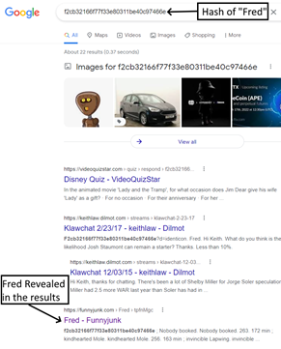

“Salt” is the inclusion of additional data alongside the password before hashing to prevent the use of large dictionaries of hashed values to decrypt the password. Many unsalted hashes of common words and names can easily be revealed using google.

Conclusion:

Due to speed not being a huge issue as it is only being used to hash the passwords when creating and verifying a password, I believe that Argon2 is the best option to use for my project for its high security and easy implementation. Argon2 also won the Password Hashing Competition.

I wanted to see if it was possible to integrate Argon2 into Python, so I created a simple script that takes an input and verifies it against a hashed password and outputs True or False based on whether the input matches the password:



This if statement checks If the hash has been created, and if it has not been it creates the hash and saves it to test.txt

Opens test.txt and assigns the hash variable as what’s in the file

Imports the argon2 Python module

The contents of test.txt, which stores the hash of the password.

Checks if the hash is out of date and replaces the outdated hash with a new updated hash.

Checks the user input against the stored hash and outputs True or False based of the result.



Using the correct password it outputs True, as expected.

Using the incorrect password it outputs False, as expected.

Console output:

After creating this script and making sure it is easy to integrate into Python. I feel comfortable integrating it into my project to store passwords and to increase security.

#### Encrypt network activity

When researching what algorithms or methods I could use to encrypt the network messages I found an encryption algorithm called AES which is a symmetric block cipher.

This algorithm looked promising, so I created a small encrypt/decrypt script:

When creating this script, I decided that it would be more secure if the day, month and current hour are all used to help make the second key or IV.



Imports the AES encryption and datetime Python modules.

These are the variables for the Key and IV. The IV (key2) changes based off the Hour, day and month the code is run on, so you never get the same number.

This while statement checks that the message is 16 bytes long as the algorithm requires that, it also records how many padding characters it used so they can be removed after decryption.

The function then returns the encrypted string and how much padding was used.

This decrypts the string and removes all the padding which is then returned.

This runs both the functions with ‘#MesSagE63’ as the message and outputs the values that are returned throughout the process.

Console Output:

This is the encrypted string that would be transmitted and it has 5 padding characters.

It outputted the same value that was encrypted, this shows that it works perfectly.

Conclusion:

After creating this script I feel comfortable using the AES algorithm to encrypt the network traffic that will be sent back and forth.

### GDPR and Data Protection Act

Due to the new laws in place I need to ask for permission before storing any personal data and be able to remove or locate and send all data linked to them if requested.

As I will not be storing any sensitive data such as credit information or full name, this means that it will not cause me any great issues. To abide by these rules, I will have a tick box to allow me to store their username and password and any messages they send, and if someone requests their data then all databases will be searched with their username and will send it over to them.

## Comparison of Existing Programs

Currently there is a [Official Formula 1 Fantasy](https://fantasy.formula1.com/) web application that is similar to what I would like to achieve. I hope to compete with this program in the future.



Shows next race to be held.

Shows your created teams.

Shows each driver’s name what team they are in and a photo of them, to help anyone that may be confused.

Shows how the price/value of that driver has changed recently, to help people make good decisions about their drivers



The Official Formula1 Fantasy program has lots of good features but does not provide a chatroom to be able to talk with other people about the sport or about their program, this is what my project will include to bring the community together.

When browsing the website, I liked the recent price/value change as this helps people make informed decisions to add their drivers, so I have decided to try and add this to my project to show the change in price over 2 races.

I also saw that they have lots of animated graphics that I do not have the skill or time to implement as I will focus on the minimum viable product.

Their website also includes advertisements, many users may find this annoying and intrusive, so my project will not include any advertising or sponsored content as I do not intend to make money from this program at this current time.

## Feasibility Conclusion

I used my research described above to answer the feasibility questions I raised earlier

1. The Ergast Developer API is a free to use API that provides all of the data needed for:

* The list of drivers
* The list of Constructors
* Previous Race Results

2. The scoring rules, while complex, are well defined and can be coded computationally. The rules are documented in “Points System” of the Design section below.

3. As each user needs to only see their own data, I need to investigate approaches to implement a secure login for each user. I’ve investigated both Hashing and encryption approaches to make a secure login and authentication system.

4. The system will not store personal data, only the username and a hash of the password, so is not severely affected by GDPR regulations.

The result of all of this research together with the fact that there is a similar computer-based Formula One fantasy league system shows that this is a feasible problem to implement with a computer based solution, and should be possible to build an MVP solution within an A level coursework project.

## Limitations of the MVP

The initial MVP developed during this project will have the following limitations:

* The system will not consider changes over multiple years of racing, Users will create a new team for each race year,
* The system will only cover Formula One, and no other forms of motor sport.
* The system will only be tested supporting 3 concurrent users
* The system will initially be deployed on my local computer and will not be available when it is switched off.
* The system will initially only be accessible within the local network of the server and will not be accessible from the internet.

## Requirements

The system will require the following:

Software:

* A client user interface for users to:
  + Create and edit their team
  + See updates to their team scores with new race data
  + Chat to players
* A server to:
  + Gather Driver, constructor and Race data
  + Calculate and score driver, constructor scores and values
  + Store users selected teams
  + Update teams values based on new race data
  + Support a broadcast social chat system

Hardware:

* Server
  + 4+ CPU Threads
  + 2+GB Memory
  + 1+GB Storage space
  + Connected to the internet
* Client
  + 2+ CPU Threads
  + 1+GB Memory
  + 5+MB Storage space
  + Connected to the server LAN (or in the future the internet)

During development both the client and server will be run on the same hardware using the localhost loopback ip address.

Development:

* Python 3.8+
* PyCharm community edition, integrated development environment or repl.it an online interpreter.

# Design

The system as a whole is complex, so to make it easier to understand I broke it down into the following components.

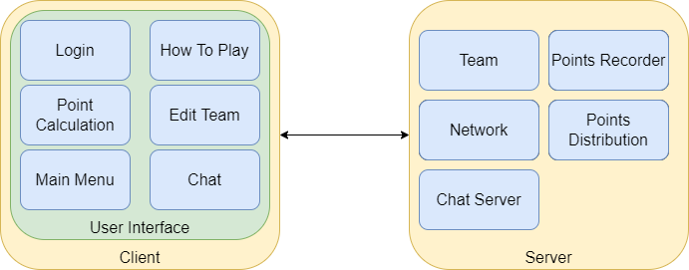

I initially identified what the major components that are needed, and then assigned them to either the client or server, with user interface aspects being within the client user interface and storage calculation and wider communication at the server.

User Interface Components:

* Login - Will handle user login and registration of new accounts.
* How To Play - Will display a set of instructions of how to build and develop your team.
* Point Calculation - Will display the point calculation rules for the user.
* Edit Team - Will allow a team to be built and edited, from a constructor and a team of drivers with a limited amount of money.
* Main Menu - Will display the current team, current team value, the next race and buttons to access the rest of the application.
* Chat - Will allow social broadcast chat messages amongst all the players.

Server Components:

* Team - Will store the selected team for each user
* Points Recorder - Will gather race data, and calculate the points for each driver and constructor
* Network - Will handle the communication with the clients and user login and account registration
* Points Distribution - Details How the race results are turned into points values
* Chat Server - Supports the chat system sending out any chat message to all attached clients.

The detailed designs of the following components will be further detailed in sections below:

1. Server Login
2. GUI - the graphical user interface
3. Scoring and the points system
4. The client-server chat system

## Server Login

For my login page I would like to have a username and password login system so that the username can be used later for the chatroom. I designed a flowchart of what the algorithm will be doing:



This flowchart will help me write the login page and help understand how it needs to work.

This flowchart diagram does not include any encryption on the data before sending it to the server but the actual project should incorporate this.

I have designed a simple design for what the login page should look like on the client side.



Title and Logo to engage the user.

Fields to enter the username and password.

A tick box to accept Terms and conditions which contain how their data will be used so I do not violate any GDPR laws.

When submitted it closes the window and sends the data over to the server.

Currently I have no logo or a design choice so the design only consists of what is needed for the login page to function as aesthetics can easily be added or changed in the future. This design was improved as part of the GUI design to help match the design of the other pages.

## GUI

From my stakeholder interview the GUI needs to:

* Be easy to navigate.
* Show the users team value and recent changes.
* Provide easy to use chat.

So, I designed a wireframe of what each page would look like to make sure I include all the features that are required:

Menu:



* The buttons to the left provide easy access to all of the functions of the application.
* The Centre section displays the user’s team and recent changes in their value, as well as a button to edit the team.
* The right side allows users to enter chat messages, and see what others are sending.

Team edit screen:



* The left hand side displays the current team, its value and the amount of money left to spend.
* The right hand side allows the driver team and constructor team to be selected, and the submit button saves those changes.

Login and register pages:



* The dialog box to the left shows the login page where the user can enter their user name and password (which is masked). A Sign up button allows new users to change to the screen on the right to register a new account.
* The dialog box to the right allows new users to create a new account by entering their username and a chosen password twice (both masked). A checkbox allows them to accept the terms and conditions, and a link allows them to view them.

Recent driver changes page:



* This screen shows the recent changes in values of the drivers and constructors as a read only list
* It is not part of the Required Features and will only be implemented if time allows

This gives me a reference for when I am creating the GUI so that it can be as close to my visions as possible.

**Wireframe Storyboard:**

Making a GUI page diagram will help show how to get to the different pages of the GUI through the button menu. This shows how navigation in my program will work and how to implement it, ensuring that the result satisfies the required feature of “A good-looking GUI to show all the data needed and provide a way around the program”.



## Points System

As the entire project relies on the value of teams and drivers changing and adapting, the points need to be allocated correctly and fairly. I have created a points list that can be integrated into the program during development, and which can easily be changed later.

All Drivers and Constructors will start with a base of 250 points, to stop any negative values.

Driver:

Qualifying Points:

Pole position / +3 Points

Second / +2 Points

Third / +1 Point

Made it into Q2 / +5 Points

Made it into Q3 / +5 Points

Qualified better than teammate / +3 Points

Qualified worse than teammate / -2 Points

Race Points:

|  |  |
| --- | --- |
| Race position | Points |
| 1 | 25 |
| 2 | 18 |
| 3 | 15 |
| 4 | 12 |
| 5 | 10 |
| 6 | 8 |
| 7 | 6 |
| 8 | 4 |
| 9 | 2 |
| 10 | 1 |
| 11-20 | 0 |

Race finish / Points as show in table

Fastest Lap / +1 Point

Positions gained from grid / +1 Point per position gained

Positions lost from grid / -1 Point per position lost

Finished above teammate / +3 Points

Finished below teammate / -3 Points

Did Not Finish (DNF) / -25

Constructor:

Qualifying Points:

Driver on pole position / +3 Points

Driver second / +2 Points

Driver Third / +1 Point

Driver made into Q2 / +5 Points per driver

Driver made into Q3 / +5 Points per driver

Both drivers made it into Q3 / +3 Points

Race Points:

Race finish / Points per driver as shown in table

Fastest Lap / +1 Point

Driver positions gained from grid / +1 Point per driver

Driver positions lost from grid / -1 Point per driver

Driver Did Not Finish (DNF) / -25 Points per driver

Finished top 10 / +3 Points

Each user will start with ₤100,000,000 to create their team. Driver and Constructor points will be converted into currency by multiplying their point values by 10.

Here is a flowchart the calculation for points:



Times points by 10

## Client Server Chat

For the client-server chat I created a flow chart for how it would work on the server and on the client so that it would be easier to properly integrate and add it to my project.

**Server:**



**Client:**



These flowcharts were very helpful as they showed me I would have to make use of multithreading in my project to be able to send and receive messages at the same time.

## Database Structure

For my project I will be using SQLite3 as it is very well integrated into Python, so will be the most simple to set up.

I will need at least 2 tables, one for login details, and one for the user’s team data, with the formats below.

Login table:

|  |  |  |
| --- | --- | --- |
| UserID | Username | Password hash |
| Unique Integer | String | String |

This will store the username and the hash of the password for each user, only the hashed value of the password is stored to minimise the impact of any data breaches or leaks as users frequently use the same password on multiple systems.

Team Data table:

|  |  |  |  |
| --- | --- | --- | --- |
| UserID | Constructor | Remaining Drivers | Remaining cash |
| Unique Integer | string | List stored as a string | Integer |

This will store the team selections for each user, with one constructor and five drivers making up a team, any remaining cash values is also stored as an integer.

## Development Method

For my development I will be using modified RAD (Rapid Action Development) methodology so that with each iteration I can make a prototype and get feedback from the stakeholders on how to improve or adapt the project to help meet deadlines or to make a better product. This means I may improve my project design as development progresses.



Using this diagram I created, at the start of each iteration I will set an expectation list to complete each week then design, implement and test the new code. Stakeholder’s feedback will help me evaluate that week to help set the expectation for the next week. This means if I set an expectation that is too much work for that iteration, I can move it over to the next iteration and expect a more reasonable amount of work, or if I set my expectation too low I can increase what is expected for the next iteration.

During development I will also be constantly committing my code on GitHub. This will allow me to have version control, so I can roll back to any point if I create an unwanted error or for any other reason.

## Test Plan

I plan to perform testing on the functionality created each week to identify if each task is completed, or if any bugs are apparent and to help inform future development.

In addition, I will perform system tests after development to ensure all of the implemented functionality works and this will allow me to assess the complete solution against the initial prioritised requirements and success criteria.

### Test Data

For test data during the early development iterations, I will use saved download of the race and driver results until the live download from the API is developed.

This will allow rapid development and testing without repeatedly downloading the same data from the API and reduce the load on the API.

During development I may use a smaller subset of just this year's race data while developing the scoring system, which will be faster to process and spot any errors.

At the end of each iteration, I will test that the system could operate with the full dataset from the Ergast Developer API, which is the data source for race data that will be used to run my program after development is complete.

# Development

## Week 1 – Creating Points Distribution

This week I would like to get a server prototype up and running, to do this I need to:

* Get the server to a connectable status.
* Create a points distribution, a file that contains the point values for different tasks.
* Get the server to fetch and sort the information from Ergast F1 API and store the data for each race that has taken place.
* Use the data to calculate and store the points for each driver and constructor.
* Check if the points system creates fair point distribution.

I started by creating a separate JSON format Python file to store the amounts of points gained and lost through tasks completed by the drivers.

#points_distribution.py

#Points given for tasks  
assign_points={  
 'DriverPoints':{  
 'Race':{  
 'Results':{  
 '1':25,  
 '2':18,  
 '3':15,  
 '4':12,  
 '5':10,  
 '6':8,  
 '7':6,  
 '8':4,  
 '9':2,  
 '10':1,  
 'F':-25, #F,D,W,R,N is DNF  
 'D':-25,  
 'W':-25,  
 'R':-25,  
 'N':-25  
 },  
 'fLap':1, #Fastest Lap  
 'PGFG':1, #Points per Position gained From grid  
 'PLFG':-1, #Points per Position lost From grid  
 'FAT':3, #Finished above teammate  
 'FBT':-3, #Finished below teammate  
 },  
 'Qualifying':{  
 'Results':{  
 '1':3,  
 '2':2,  
 '3':1,  
 },  
 'RQ2':5, #Reached Q2  
 'RQ3':5, #Reached Q3  
 'QBT':3, #Quallified Below Teammate  
 'QWT':-3 #Quallified Above Teammate  
  
 },  
 'Constructor':{  
 'Race':{  
 'Results':{  
 '1':25+3,  
 '2':18+3,  
 '3':15+3,  
 '4':12+3,  
 '5':10+3,  
 '6':8+3,  
 '7':6+3,  
 '8':4+3,  
 '9':2+3,  
 '10':1+3,  
 'F':-25, #F,D,W,R,N is DNF  
 'D':-25,  
 'W':-25,  
 'R':-25,  
 'N':-25  
 },  
 'fLap':1, #Fastest Lap  
 'PGFG':1, #Points per Position gained From grid  
 'PLFG':-1, #Points per Position lost From grid  
 },  
 'Qualiflying':{  
 'Results':{  
 '1':3,  
 '2':2,  
 '3':1,  
 },  
 'RQ2':5, #DriverReached Q2  
 'RQ3':5, #Driver Reached Q3  
 'BQ3':3, #Both drivers reach Q3  
 }  
 }  
 }  
  
}

I also created the start of the points recorder for each driver, and it will record the names of all f1 drivers

import requests #import needed modules  
import ast  
def get_drivers():  
 data = requests.get('http://ergast.com/api/f1/drivers.json?limit=1900&offset=30')  
 drivers = ast.literal_eval(data.content.decode())['MRData']['DriverTable']['Drivers']  
 detail_driver_list = []  
 file = open('drivers.txt', 'w+')  
 for driver in drivers:  
 try:  
 driver_id = driver['driverId']  
 full_name = f"{driver['givenName']} {driver['familyName']}"  
 nationality = driver['nationality']  
 DoB = driver['dateOfBirth']  
 number = driver['permanentNumber']  
 except Exception:  
 number = 'n/a'  
 detail_driver_list.append([driver_id,full_name,nationality,DoB,number])  
 file.write(str(detail_driver_list))  
  
def get_race_data():  
 from datetime import date  
 for year in range(1950,date.today().year+1): #Cycle through all years of f1  
 total_races_in_year = ast.literal_eval(requests.get(f'http://ergast.com/api/f1/{year}.json').content.decode())['MRData']['total'] #Get all rounds in the year  
 for race in range(1,int(total_races_in_year)+1): #Cycle through all the rounds in the year  
 race_data = ast.literal_eval(requests.get(f'http://ergast.com/api/f1/{year}/{race}/results.json').content.decode()) #Get the race data   
 quali_data = ast.literal_eval(requests.get(f'http://ergast.com/api/f1/{year}/{race}/qualifying.json').content.decode()) #Get the quali data  
 assign_driver_points(race_data, quali_data)  
  
def assign_driver_points(rData, qData): #use race data to assign points to the driver  
 #print(len(rData['MRData']['RaceTable']['Races'][0]['Results']))  
 for driver in rData['MRData']['RaceTable']['Races'][0]['Results']:  
 driver_id = driver['Driver']['driverId']  
 finish_position = driver['position']  
 grid_position = driver['grid']  
 constructor = driver['Constructor']['name']  
 try: fastest_lap_position = driver['FastestLap']['rank']  
 except KeyError: fastest_lap_position = 22  
 driver_points = get_race_points(finish_position ,grid_position ,constructor ,teammate_position , fastest_lap_position)  
  
def get_race_points(fPos, gPos, team, teammatePos, fLapPos): #Get all data required and create  
 points = 0  
 from point_distribution import assign_points  
 try: points = points + assign_points['DriverPoints']['Race']['Results'][fPos] #add points for finishing finishing top 10 or minus 25 for not finishing  
 except KeyError: points = 0  
 points = points + ((int(gPos)-int(fPos)*assign_points['DriverPoints']['Race']['PGFG'])) #add points for position gained from grid  
 if fLapPos == 1: points = points + assign_points['DriverPoints']['Race']['fLap'] #add points for achiving fastest lap  
 if fPos > teammatePos: points = points + assign_points['DriverPoints']['Race']['FAT'] #add points for finishing above teammate  
 elif fPos < teammatePos: points = points + assign_points['DriverPoints']['Race']['DBT'] #add points for finishing below teammate  
   
 return points  
  
get_drivers()  
get_race_data()

Due to the research and lack of knowledge the points calculation is taking longer than expected and I was doubting the efficiency due to my program having a Big O notation of O(n2) and as the data sets it has to go through are large and requesting them takes time I was worried about the efficiency of this algorithm before I had finished it, and it would have to include another loop for each team, so I decided to create a new flowchart for my points system which gets each driver of a team’s points at the same time:

This new algorithm uses fewer loops to bring down the runtime of the points calculator and will make use of multiprocessing on the subprocess so that it can run even quicker.

This also allows me to calculate each team’s drivers and calculate the constructor’s points all at once removing the need for another loop.



### Iterative Development Testing:

|  |  |  |
| --- | --- | --- |
| **Test Case** | **Pass / Fail** | **Comments** |
| Be able to connect to the server | Fail | This was not implemented this week, but this is not important until later weeks when the client and login process are built. |
| Have a points distribution file | Pass |  |
| Fetch, sort and store the information from Ergast F1 API | Partial | It can fetch and could start to sort the data for the drivers but does not store it |
| Calculate each drivers’ points | Partial | This works but can take a long time due to the number of nested loops calculating the drivers points from the race data. |
| Calculate the Constructor’s points | Fail | This was not implemented in this week, and my algorithm was incapable of doing this in its current setup, which is the reason a new algorithm was formed |
| Check if the points system creates fair point distribution | Fail | This cannot be tested until the Drivers and Constructors points are implemented. |

### Conclusion

I made good progress on understanding the race data and how to process this to extract the drivers point scores, however I underestimated the complexity of the data and this work, and the initial performance of calculating the Drivers points was not as fast as I would like, and was not able to calculate the constructors points at the same time, so I created a new algorithm that can calculate both the drivers points and constructors points at the same time and can be stored together making everything less complicated and resource intensive.

Overall, I overestimated what I would be able to achieve in the first week and will need to plan less in the following weeks. The areas that I did not achieve in this week will be addressed in the next few weeks.

## Week 2 – Points Calculation Algorithm

Last week I decided to remake the points calculation algorithm as it did not include a way to calculate constructor’s points and had long runtime due to many nested loops

This week I would like to get the points system up and running, to do this I need to:

* Get the server to fetch and sort the information from Ergast F1 API and evaluate the data for each race that has taken place.
* Use the data to calculate and store the points for each driver and constructor for every race.
* Store this data to an external database/file.
* Check if the points system creates fair point distribution.

I was able to get the points gained and lost for teams and drivers for every race, but this does not make any use of qualifying data which also needs to be included, and it does not store the data to storage yet.

The code I have created this week gets the race data of every year by getting all the data from every race, process it and prints the points values for every race.

This subroutine cycles through the years, gets the number of races that year and then cycles through each race that year, where it then gets the race and qualifying data and provides it to the assign_driver_points subroutine.



The assign_driver_points subroutine extracts the data required and creates a new data structure, filtering the data required and restructures the data into a dictionary with the constructor as the key, this combines drivers with the team they drive for. It then cycles through each team and provides both drivers’ data to the get_points subroutine.

The get_points Subroutine uses both drivers data to assign points based on tasks they completed. It uses the numbers from point_distribution.py to get the total points for each task, then returns the calculated points for each driver and the team.

This code only currently makes use of the race data, so I know next week I need to have it include race data and to save all this data to a file.

### Iterative Development Testing:

|  |  |  |
| --- | --- | --- |
| **Test Case** | **Pass / Fail** | **Comments** |
| Fetch and sort the information from Ergast F1 API | Partial | This currently uses the points gained and lost for each race but does not use the qualifying data yet |
| Store this data to an external database/file | Fail | This was not implemented in this week |
| Calculate each drivers’ points | Partial | It records the points gained/ lost for each race but does not total them. It is also still too slow. |
| Calculate the constructor’s points | Partial | It records the points gained/ lost for each race, but does not total them |
| Check if the points system creates fair point distribution | Fail | This was not implemented in this week |

### Conclusion

I made good progress on the race points system, getting the live data from the API, and adjusting the points calculation to also work out the constructor’s points. I still have to address the performance of calculating the driver’s points.

I’m still overestimating the tasks that can be achieved within a week.

## Week 3 – Saving Raw Points

This week I would like to get the points system finally up and running, to do this I need to:

* Use the qualifying data and extract points required to add to the race points.
* Make use of threading to speed up the calculations.
* Make the current year worth 10x more points.
* Store this data to an external database/file.
* Check if the points system creates fair point distribution.

When researching to add qualifying data to my program I realised the qualifying result is the same as their starting position on the grid so I can just use the already created gPos variable to assign points

When I started programming I noticed an issue with using the created gPos variable, anyone that took engine penalties or other kind of grid penalties would not gain points for their qualifying position, I decided that to help the runtime and simplify the code that for now it will use the starting grid position of the drivers, if this creates issues in the results of the points then I can introduce it back at a later date.

I started by adding threading to the code so that all the years would run in parallel instead of through nested loops, which dramatically decreases runtime.

It creates a thread for every year and then loops through the list of threads and runs them, then it waits for the last thread to finish before continuing the code. This reduced the runtime from about 92 seconds to 21 seconds.

I also added the qualifying points based of the grid position of each driver

This means that it now calculates all the points it needs to.

Then to save them to a file I created a subroutine save_points that is called in the assign_driver_points file after using the data from the get_points subroutine.



This means that all the points created by the code will be recorded.

I altered the save_points subroutine so that it multiplies the points of any race in the current year by 10x

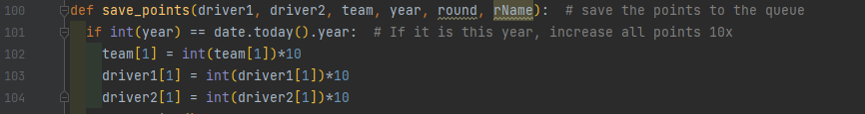

I have noticed one issue when I run the code, and that is that the file created is always a different size, I assume it is due to two threads writing to the file at exactly the same time, so I will need to address this next week.

### Development Testing

|  |  |  |
| --- | --- | --- |
| **Test Case** | **Pass / Fail** | **Comments** |
| Use the qualifying data and extract points required to add to the race points | Pass |  |
| Make use of threading to speed up the calculations | Partial | The calculation is much faster, but the resulting file size can differ suggesting a problem with multiple threads writing to the file at the same time. |
| Make the current year 10x the points for each race. | Pass |  |
| Store this data to an external database/file | Pass | The raw race data is saved into the points.csv file |
| Check if the points system creates fair point distribution | Pass | Addressed by x10 the current years points |

### Conclusion

The use of threading has made a great improvement to the performance of calculating the drivers scores. In addition, I was able to include the qualifying data and include that into the points calculations. To improve the points distribution, I chose to multiply the points by 10 for the current year, to make the current year the most relevant.

I did spot that the output file size can vary, which should not be the case, and I’ll need to investigate this in the next week.

## Week 4 – Threading Points Calculation

Last week I added the calculation of qualifying data, and made use of threading to speed up the time in which the code takes to run, but by making use of threading it caused an issue where some data was being deleted as art o a race condition between threads.

This week I would like to fix the issues caused by threading, to do this I need to:

* Find an alternative to writing straight to the file.
* Maybe slow down the threads.
* Make sure no data is being deleted

When searching for a solution I found a thread safe [Python queue module](https://docs.python.org/3/library/queue.html) that is a queue data structure, which is thread safe for multiple thread inserting data simultaneously. So I would be able to have all the threads added to the queue and a loop running in parallel that takes data from the queue and writes it to the list.

I started integrating the queue module by initialising the queue at the start of the get_race_data subroutine



I had to make the “q” and “finished” variables global so that the save_to_file loop and each thread could access the data they need.

The save_points subroutine only had to be changed slightly so that instead of saving to a file it just adds to the queue.



Then the save_to_file subroutine has to take the data from the queue and write it to the external data file.



I decided to run the save_to_file subroutine in parallel with the threads by adding it to the start of the list of threads that will be executed and it waits for the save_to_file thread to finish before moving on.

But as the bug which deleted some data through threads writing to the same area at the same time did not go away completely, I decided to add a break for every 10 threads so that it has no chance to delete any needed data.

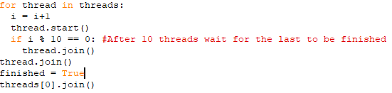

Even with this change it runs much quicker than without threading and barely makes a difference to the total runtime.

### Development Testing

|  |  |  |
| --- | --- | --- |
| **Test Case** | **Pass / Fail** | **Comments** |
| Ensure all the data is calculated and output each time (this test covers all 3 tasks for this week). | Pass | Repeated runs of the code created the same output file size and content. |

### Conclusion

I introduced a thread safe queue to buffer the output of the results to a file with a single thread reading from the queue and writing the file. This fixed the problem that some of the data was being deleted and only had a minimal effect on performance.

This week I had to learn about issues and fixes for multi threaded code, and how to use thread safe queue structures to avoid race conditions.

## Week 5 – Final Points Calculation

Last week I fixed a major issue with data deletion and implemented a queue system to get that done. This was very helpful and now means I can move on and finish the points calculation and start the user interface and network for the project.

This week I would like to total the points and save them to a file which can easily be navigated, to do this I need to:

* Analyse the raw data.
* Total each driver’s points from both driver1 and driver2 data.
* Total each team’s points from the raw data.
* Save each driver’s points and team points in an easy to navigate data format.

So I created a subroutine that reads the raw data file and takes the team and each driver’s points and groups them with their drivers then totals the points, sorts them and saves the results as a json file and a separate json file for the team points.

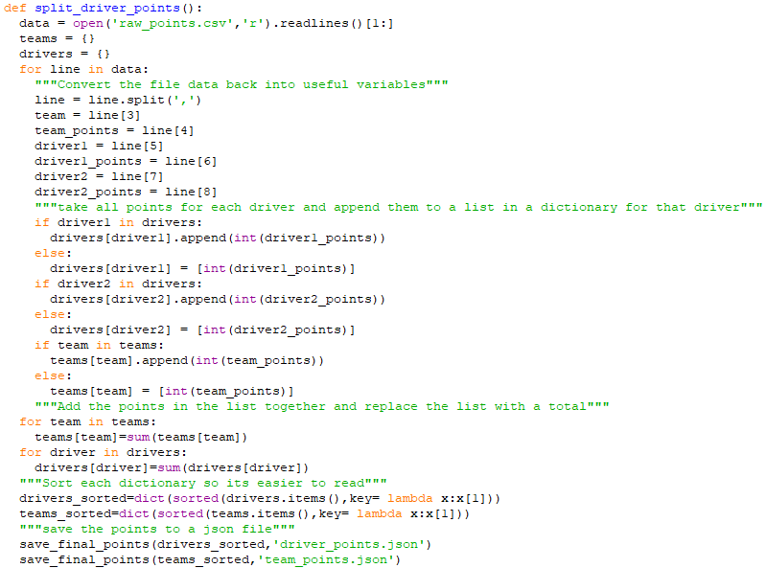

I noticed I had coded some repetition into my code so I created a list of a list of variables that are used in each loop and then created a loop for each item in the list as shown below.

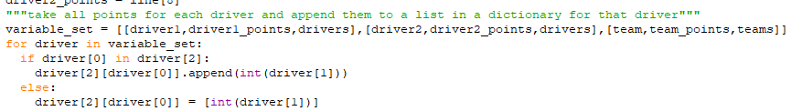

The save_final_points subroutine just takes the data and filename in and saves the data into the file and changes all ‘ into “ as required for the json format.

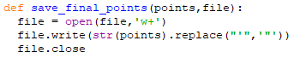

This creates two files driver_points.json and team_points.json.

A snippet of driver_points.json looks like this

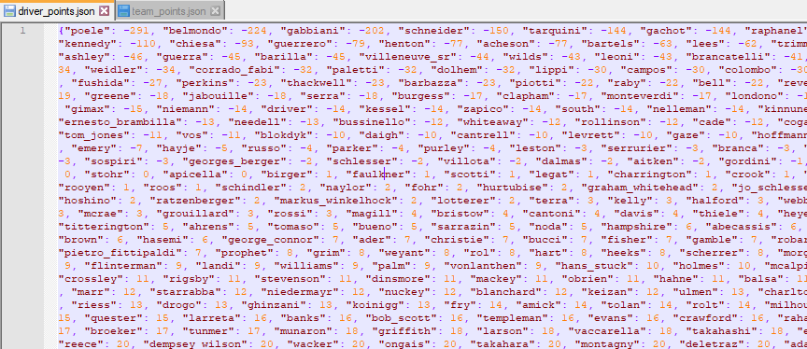

And team_points.json looks like this

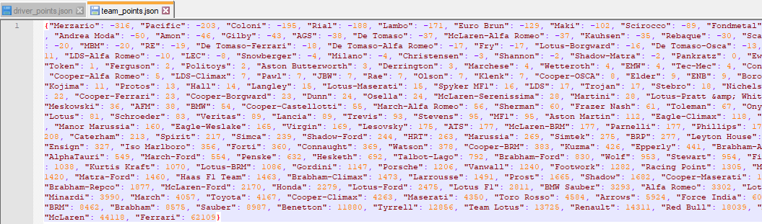

The screenshots don’t show all the data but show how the data is stored and how it will be navigated when used later.

When I ran the code I noticed lots of teams that have been in the sport for a long time such as Ferrari and Williams came out as the highest points, so to counter this I decided to x10 all points in the most recent season. I did this by changing the points value just before it is saved.



### Development Testing

|  |  |  |
| --- | --- | --- |
| **Test Case** | **Pass / Fail** | **Comments** |
| Analyse the raw data | Pass |  |
| Total each driver’s points from both driver1 and driver2 data | Pass |  |
| Total each constructor’s points from the raw data | Pass |  |
| Save each driver's points and team points in an easy to navigate data format | Pass | JSON files are saved for the drivers and constructors |

### Conclusion

This completed the points calculation work, this took longer than I initially estimated, but I had not considered that the volume and complexity of the data would need the use of multi-threaded code to calculate in a reasonable amount of time and the problems that were introduced with multiple threads writing to the same file.

## Week 6 – Server-User Login

Last week I finished the calculation and recording of team and driver points. So, this week I want to start the server-user login to a base level so that it can be incorporated into the GUI.

To start the code for the client-server login I need to:

* Create a connection between the client and server
* Send the login information to the server
* The server needs to take the data, hash the password compare them and accept or decline the client
* Then both the server and the client need to proceed through their code.

Before I created the client-server login I decided to move all the files that are to do with points calculation into a separate file to keep the project organised

So the project folder looks like this when it is run.



To do this I needed to change all references to other files such that they are placed and looked for inside the points folder. But this will help to keep my project tidy and easy to navigate.

To start the login page I need to create the frame of what the program would need to make use of in the backend.

I started by creating an SQL database for the login information and link it to the Python file



This creates a table called logins with 2 columns, username and hashpass to store the usernames and passwords and imports the hashing algorithm so that it can verify hashes.

I then created the class that handles each user that logs on.



The ‘Account’ class uses the username and finds the connected password hash if there is one, and the account variable states whether there is an account under this name which can be checked if valid_account() is run. Then if it is a valid account it can run check_pass() which takes the given password and verifies it against the hash value.

To make use of this class a simple subroutine needs to be created.



I created a login subroutine which uses the account username and the password given and then checks if the username is valid by running check_pass() with the given password which can then return a true or false, and the false has a reason attached.

I now need to create a subroutine and method to register an account into the database.



This subroutine uses the username to check if there is already an account and if there is not then it runs the create_record() method.



This method inserts the username and password and also increments until it finds an open ID value. This is only possible because I changed the table initialiser to only accept unique values

This week I was able to complete the server side backend and database that will take, compare and register new accounts. This structure can be built on next week to start working on sockets and connecting to the client.

### Development Testing

|  |  |  |
| --- | --- | --- |
| **Test Case** | **Pass / Fail** | **Comments** |
| Create a connection between the client and server | Fail | Due to time constrains I was not able to create the client code, so no link can occur. |
| Send the login information to the server | Fail | As there is not a client-server connection yet, this is not possible |
| The server needs to take the data, hash the password compare them and accept or decline the client | Pass | The server side of the code was implemented, and the hashing algorithm works, but the client has not yet |
| Then both the server and the client need to proceed through their code | Partial | This is true for the server |

### Conclusion

I made good progress this week creating the server-side database and writing the server side of the login code. It took me longer than I planned as I needed to learn how to create and insert into the databases using sqllite3 from python.

## Week 7 – Networking for login

Last week I created the database and the methods to communicate with it and the hashing algorithm, but I was not able to incorporate networking so that will be done this week.

To continue the code for the client-server login I need to:

* Create a connection between the client and server
* Determine where the user is logging in or registering.
* Take the data and send it to the server.
* Then the server will use last week’s code to send a result back.
* Then both the server and the client need to proceed through their code.

To start I created a host connection from the server.



This opens the server, currently to localhost for testing purposes, then loops and handles multiple clients by creating a thread for each client, then waits for the thread to finish and saves the database.

The handle_client_login subroutine splits up the request from the client and runs the login or register method depending on what is needed and sends back true or false. It returns true if the client logged in with correct the username and password.

I tested my program using a small script

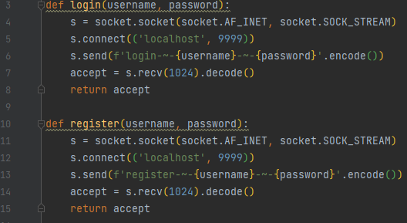

This piece of code connected and worked perfectly.

I believe some of the code will need to be moved into a main.py file so that it can be incorporated into the project properly and can easily send the team data needed

### Development Testing

|  |  |  |
| --- | --- | --- |
| **Test Case** | **Pass / Fail** | **Comments** |
| Create a connection between the client and server | Pass |  |
| Determine where the user is logging in or registering. | Pass |  |
| Send the login information to the server | Pass | From a test script at the moment |
| Then the server will use last week's code to send a result back. | Pass |  |
| Then both the server and the client need to proceed through their code | Pass |  |

### Conclusion

This week I was able to complete the server-side login and test the client-side compatibility.

## Week 8 – Create User’s Team Database

Last week I completed the login page, but it had no data to send to the client so this week I would like to set up the send and receive team data for each user’s team.

To do this I need to:

* Create a database
* Store each user’s team and 5 players
* After login send the team data to the client
* Allow addition of new team data via the client in the future

I started by creating a sqlite3 database

This creates a database that stores the team and driver data of each user

Now I need to link the different files together, I started with the points recorder



This imports the required modules and then runs the required ones to make the final sorted points files

Now I need to link the login code, so I had to move and adapt some subroutines from network.py into main.py so that the team data could also be sent.

I moved the main() and handle_client() to the main.py file so that they can easily integrate with the new database for teamdata. This code now will connect to a client, get a login or register request and check or append the database, and if the client logged in with the correct login info it will send the relevant teamdata back to the client.

Now that the different code files are linked so all the files are controlled by main.py. This is needed so that only one Python file needs to be started to launch the server

My file system looks like this, before running the code



After running the main.py file it creates these files



### Development Testing

|  |  |  |
| --- | --- | --- |
| **Test Case** | **Pass / Fail** | **Comments** |
| Create a database for team data | Pass |  |
| Store each user’s constructor and 5 players | Pass |  |
| After login send the team data to the client | Pass |  |
| Allow addition of new team data via the client in the future | Fail | This will be carried to next week |

### Conclusion

I created the database table to store the team data, and now send their team data after the client has connected.  I did not have time to add the ability to edit the data via the client, and that will have to be done next week.

## Week 9 – Add/ Get Records From Team Database

Last week I created the teamData database and allowed users to get their data from it, but currently there is no way to create new records for the database, so I need to create code that will receive the team data from the client and append this data to the database.

To do this I need to:

* Find a way to receive the data from the user
* Create a record for the data in the teamData database with the same userID
* Test that the network connection works, and the data is being saved
* Test the new data is being sent after login

First of all I need to find a way of receiving the data which needs to be added to the database. The two options I have are to create a new port and a new connection. or to use the current login connection and add a new code instead of login and register, this method would mean all connections would be done through one port which is easier to manage and understand.

First I added a new task so if the server receives the save_team request and if the username and password are valid it saves the team and driver’s data with the same userID.



I created a client test that connects to the server and sends a request to save team data,

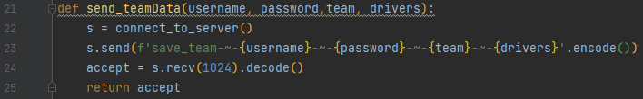



The first client test should return false as there is already a record with the username of test, the second should return True if the data has been saved to the database



These results show that the code is working as intended

Now there needs to be a way to send the team data to the client. I need to start by creating a subroutine that can get the data from the teamData table and return it.



I created this subroutine in main.py that takes in the userID, gets the related data and returns it.

Now I need to link it to the server connection.



Now after connecting to the server they can request the data if they provide the correct username and password.

I tested this new request from the server with a simple script



This worked and provided the correct data, but only if the username and password are correct.

### Development Testing

|  |  |  |
| --- | --- | --- |
| **Test Case** | **Pass / Fail** | **Comments** |
| Receive the team data from the user | Pass |  |
| Create a record for the data in the teamData database with the same userID | Pass |  |
| Test that the network connection works, and the data is being saved | Pass |  |
| Test the new data is being sent after login | Pass |  |

### Conclusion

This completes the work on the server to store and be able to update the users team.

## Week 10 – Login GUI

Last week I finished the code for the server, so I need to start working on the client. I want to start with the gui for the login as this should be the easiest to make.

To do this I need to:

* Install and set up qt software
* Create a .ui file for the login/ register page
* Link the ui file to Python code

To start I installed the Qt creator software which should allow me to start creating the .ui files for my gui.

Now using this new software I have to create these pages from my designs that can be used by the code.



I used the drag and drop interface to help when creating these pages which allowed a GUI to be made.



I used tabs so that the user can either login or register and used a list format to help keep the elements in line.

I created a text box just above the login and register buttons that can be used to display any errors if they occur.



So using these .ui files I now need to link them to some client code. First of all I created a quick piece of code that will just run and show the GUI how a user would see it but without any functionality.

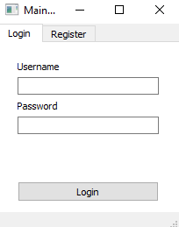

Now I have the base code that can run the .ui file I can now start integrating the buttons and text boxes as inputs and then connect to the server.

### Development Testing

|  |  |  |
| --- | --- | --- |
| **Test Case** | **Pass / Fail** | **Comments** |
| Install and set up qt software | Pass |  |
| Create a .ui file for the login/ register page | Pass |  |
| Link the .ui file to python code | Partial | I was able to launch the .ui file from python, but do not have the buttons linked to the code. |

### Conclusion

Qt is a very capable, but also complex user interface framework. Building user interfaces .ui files was easy to do once I had learned about how Qt uses different layouts and spacers to allow controls to scale as the window size changes.

## Week 11 – Login Functionality

Last week I created the GUI file and launched it in Python, so I need to work on adding use to the buttons and getting the info from the text inputs.

To do this I need to:

* Get the object names to the widgets within Python
* Link the login and register buttons to methods
* Those methods need to connect to the server
* And verify the username and password

I started by creating the initialiser that would identify all the GUI objects, and connects the signals and slots to allow widget events to be handled by functions within the code.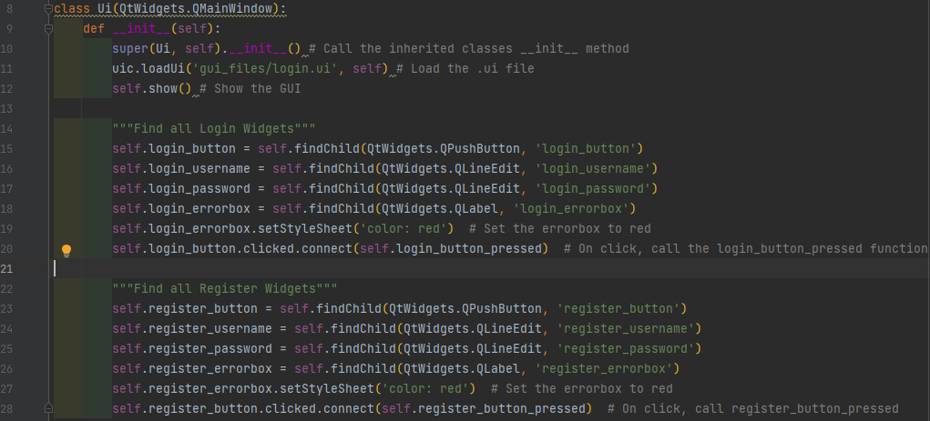

This means that any method can call any object it needs and also if the login or register buttons are pressed it runs the corresponding method.

So I need to create the login_button_pressed and the register_button_pressed methods which are called when the buttons are pressed



This login_button_pressed connects to the server if possible and displays an error message if not,, then gets the username and password from the input fields. It sends a login request to the server which if the result is True then it prints login successful, closes the login GUI and proceeds through the code.

Now I need to create the regiser_button_pressed method

This method is run when the register button is pressed. It is very similar to the login_button_pressed method as it connects to the server and gets the username and password, but it then sends a register request to the server and if the result equals True then the register window will close and the code will proceed.

Now I need to create the connect_to_server function that connects to the server using an ip and port that are in the socket_client list.



This list is stored in a file called connect.private, this is so that the ip and port can be changed in one file and it will affect any code that connects to the server.

The file just contains a list that is split across multiple lines.



Now the login functionality is completed for the server and client but may need some touching up in the future.

I created some tests to test the login code, these have also been reused for the System Testing, so are detailed in the “Login Tests” later.

Login, is test numbers L1, L2, L3

Register, is test numbers L4, L5, L6

And register and login is test number L7

The code passed all the tests which means I can now move on to other parts of the client code.

### Development Testing

|  |  |  |
| --- | --- | --- |
| **Test Case** | **Pass / Fail** | **Comments** |
| Get the object names to the widgets within Python | Pass |  |
| Link the login and register buttons to methods | Pass | I learned that Qt uses a signal and slot mechanism to link up actions on widgets to the methods in the code. |
| Connect to the server  and verify the username and password when the login and register buttons are pressed | Pass |  |

### Conclusion

I learned how to access the qt Widgets within python and link their actions to methods in my code. This allowed me to complete the login and register functionality.

As this was the first complete aspect of the system, I was able to write system tests for this allow, proving this feature works as intended, and also saving those test cases for the final evaluation.

## Week 12 – Main Window

Last week I finished the login process, so I now need to move on and create the main window GUI and add some functionality.

To do this I need to:

* Create a .ui file for the main menu
* Create a class for the menu
* Link the widgets to the Python code
* Get the users team and display it
* Add some functionality into the buttons

To start off with I need to create the Qt .ui file



I have the design diagram to help show everything I would need and where to position the widgets. 

In Qt creator I created a basic layout which is not quite the same as the design spec but includes all the functionality required.

I created a small piece of code to get the .ui file and run it to show how It will be seen when it’s used.





Currently there are a lot of placeholders in the program, as it would need to request the data from the server to write it into the GUI.

Now I need to create some basic functionality. I will start with setting up the buttons and setting them to direct towards methods that will then need to be created.



I started by creating the how_to_play button functionality



I created a small how_to_play.ui file that can then be launched when the how_to_play button is pressed. I need to incorporate that into my code.

The HTP_Dialogue_Box class just loads the .ui file and sets the title. The ok button will close the dialogue box when pressed.

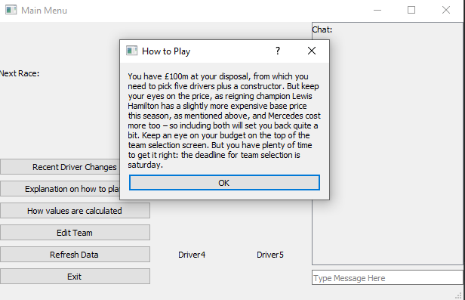

This is what the how to play dialogue box looks like. It is shown when the how to play button is pressed.

Now I need to create the “How values are calculated” button functionality.

I started by creating the .ui file in Qt Creator.

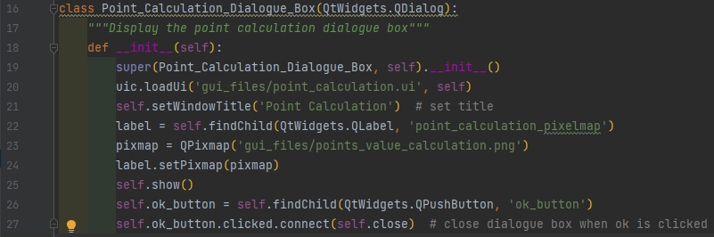I then linked the ui file and replaced the placeholder with this image

Which shows how the points are gained/ lost

Then I linked this class to the main program using a small method. 

Using the new code, when the code is run and the how values are calculated button is pressed, it shows this window.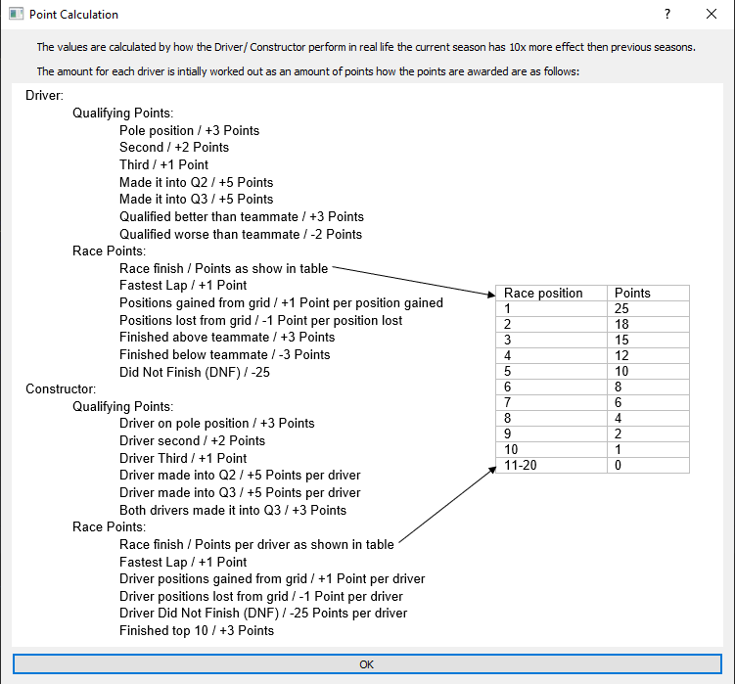

This week I was able to create the main menu and add functionality to the exit, how to play and how values are calculated buttons. I need to now add functionality to the refresh, edit team and recent driver changes buttons, and I need to be able to change the data labels on the gui to show the user the team data.

I created some tests to make sure the features are working as intended, test numbers M1, M2, M3, M4, M5

### Development Testing

|  |  |  |
| --- | --- | --- |
| **Test Case** | **Pass / Fail** | **Comments** |
| Create a .ui file for the main menu | Pass |  |
| Create a class for the menu | Pass |  |
| Link the widgets to the python code | Pass |  |
| Get the users team and display it | Fail | The placeholder for the results are in place, but not updated yet with the users team. |
| Add some functionality into the buttons | Pass |  |

### Conclusion

After having created the Login UI in previous weeks, creating the main window was much easier, and I was able to achieve much more within this week. I completed all the buttons except the “edit team” button, which will be handled next week.

I also extended the system tests with several tests covering this main menu.

## Week 13 – Edit Team Menu

Last week I started the main window GUI , so I now need to add functionality to the different buttons I want to start with the edit team button, which needs a new menu and functionality for the edit team page.

To do this I need to:

* Create a .ui file for the edit team menu
* Create a class for the menu
* Link the widgets to the Python code
* Get the point data from the server
* Allow the user to create a team
* Calculate the value of each driver
* Send the team data to the server

I started by creating the .ui file for the edit team page, with dropdown boxes to choose each player and the constructor and some labels that can be changed during runtime of the code.

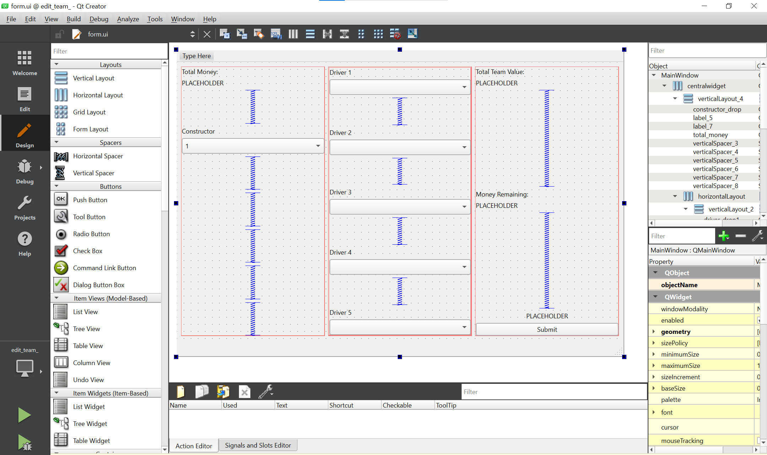

After extracting the .ui file I needed to incorporate this into my code.

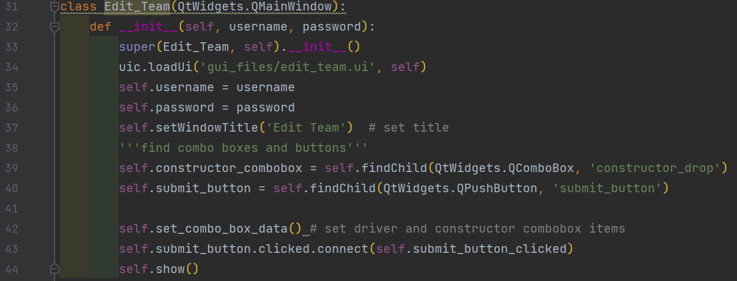

This class is used for the edit team page. It starts by loading the .ui file then assigns local variables, finds the combo boxes and buttons, then runs the set_combo_box_data() method.

Now I need to create the set_combo_box_data() method

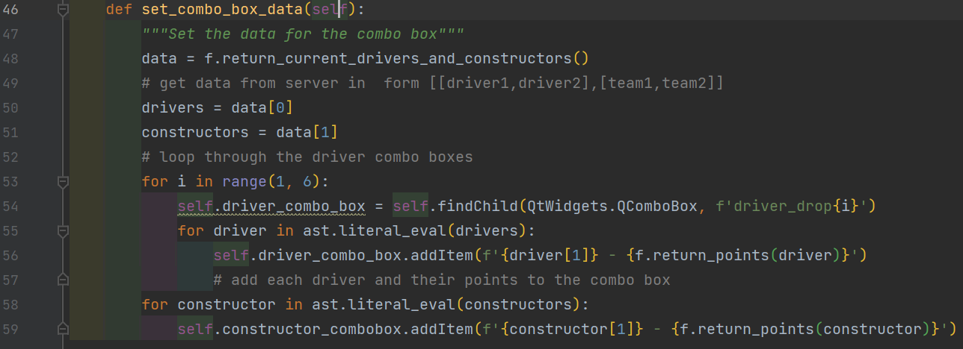

This gets the current drivers and constructors from return_current_drivers_and_constructors()

Then loops through each combo box and through each driver and adds it to each combo box with their points using a function called return points, which I will need to create.

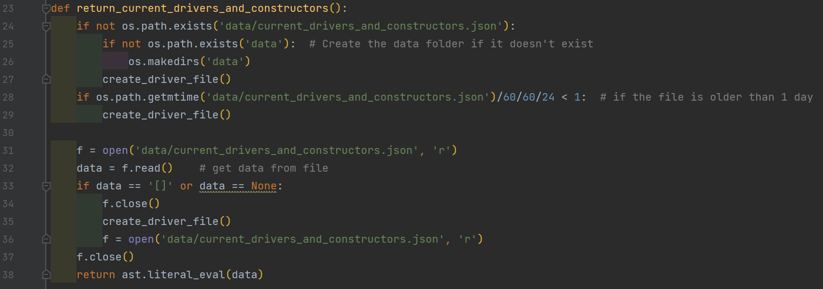

This function creates the needed directory if it does not exist. It then checks if the data file is older than a day, if so it will get fresh data by running the create_driver_file function. Otherwise, it will read the data and return it.

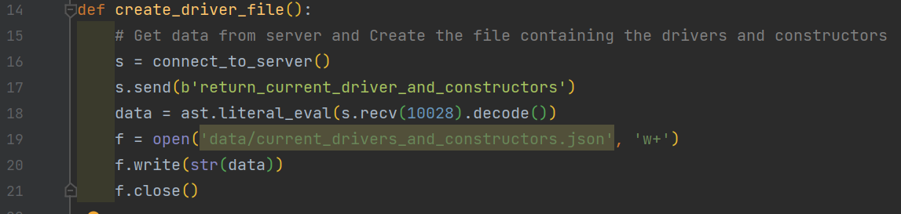

The create_driver_file function gets the data from the server and writes it into the correct file.

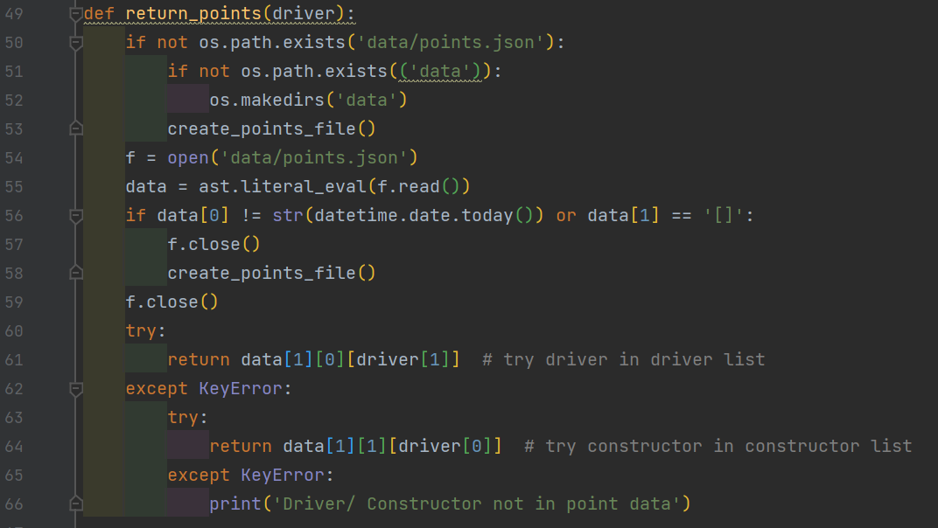

The return_points function checks if the file is present and will create the file if not, otherwise the data is stored as [date of data,[drivers, constructors]], it reads the date and if it is not the same day it will fetch new data.

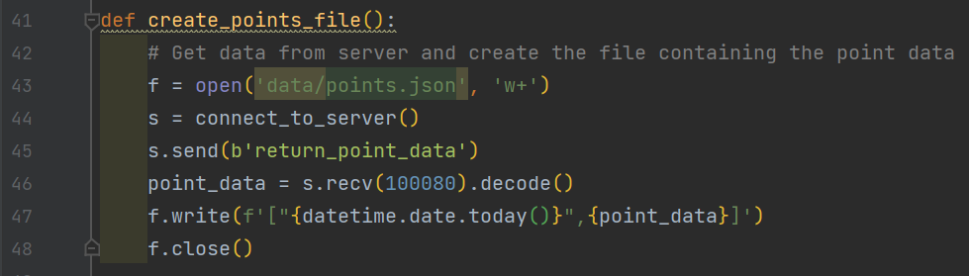

The create_points_file gets the data from the server and stores it in a data file.

Now I need to support the commands that are now being used

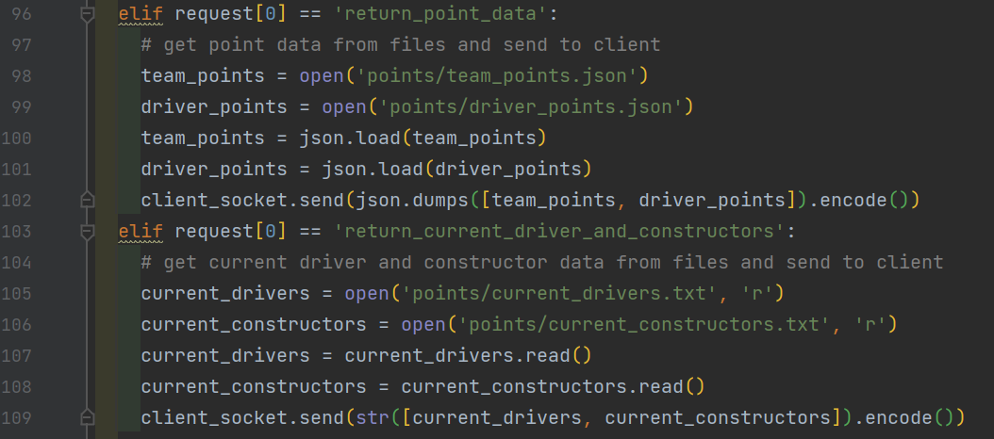

I added to the two new commands to the current requests, this means it is very well integrated.

When I first made the code for the client it did not store the data in files and would fetch it every time, this caused large wait times before the window would open, so I made it store a local copy that updates every day to reduce the wait time.

Now that the combo boxes have the correct data in them, I need the money calculation to constantly update to let the user know how much money they have left to build their team.

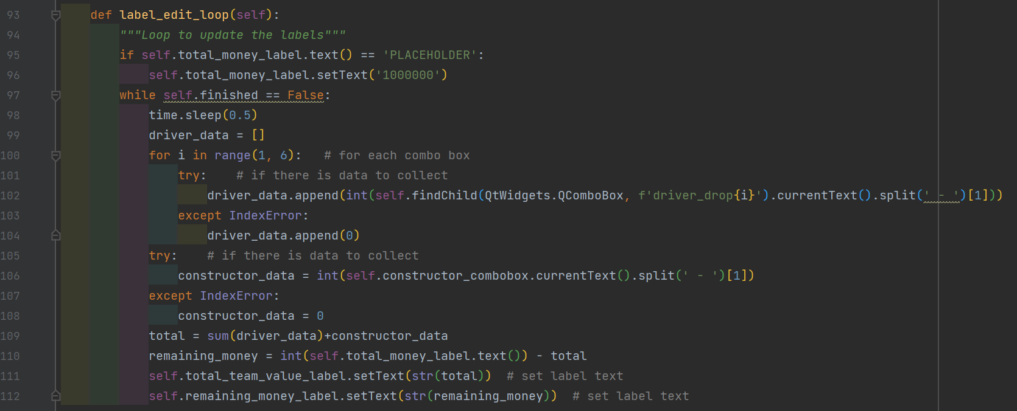

This method just loops, gets the user chosen data from each combo box then adds all the points together and sets all the labels with the correct data.

Then I used threading to run it in parallel so the user can still use the window.



Now I need to add functionality to the submit button.

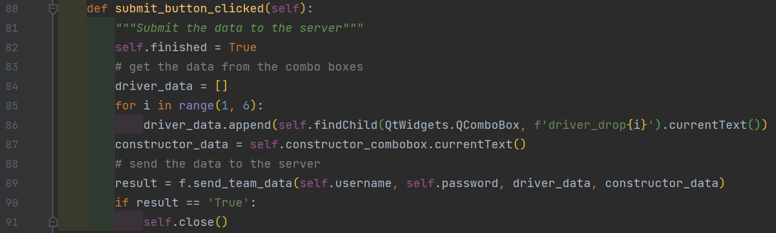

It stops the update label loop then gets all the data from each combo box and sends it to the server along with the username and password and closes the window if the data is received.

Now the edit team window has functionality.

### Development Testing

|  |  |  |
| --- | --- | --- |
| **Test Case** | **Pass / Fail** | **Comments** |
| Create a .ui file for the edit team menu | Pass |  |
| Create a class for the edit team menu | Pass |  |
| Link the widgets to the python code | Pass |  |
| Get the point data from the server | Pass |  |
| Allow the user to create a team | Pass |  |
| Calculate the value of each driver | Pass |  |
| Send the team data to the server | Pass |  |

### Conclusion

This is the most complex screen in the user interface with several inputs from the user to be able to create and edit their team.  I learned to work with combo boxes within Qt, filling the lists from the driver data.  I made use of my threading experience from earlier weeks to keep the screen interactive while continuously recalculating the remaining money available for the team.

## Week 14 – Main Menu Label Edit

Last week I created the edit team window and added functionality. This week I need to edit the labels on the main menu screen so that it shows the user’s current team stats

To do this I need to:

* Link labels to Python code
* Get the team data from the server
* Update the correct labels
* Link the refresh data button to the process
* Show the price at which the user bought the driver and the current price
* Show the percentage change of each driver in their team
* Colour the label accordingly
* Get the next race information from the server and display it

To start with I need to locate the labels and store them in the main menu class

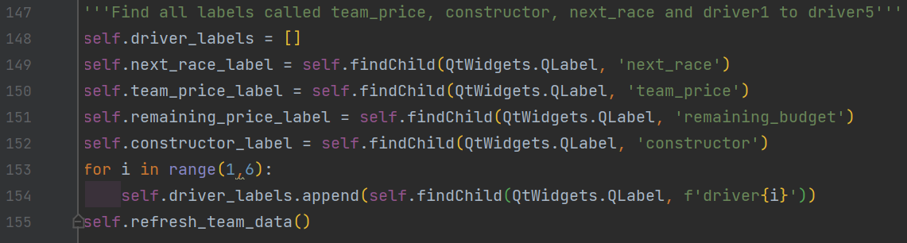

So first all the labels are located and saved as private attributes so that they can be used throughout the class. It then calls the refresh_team_data() method which will update all the labels with the correct data.

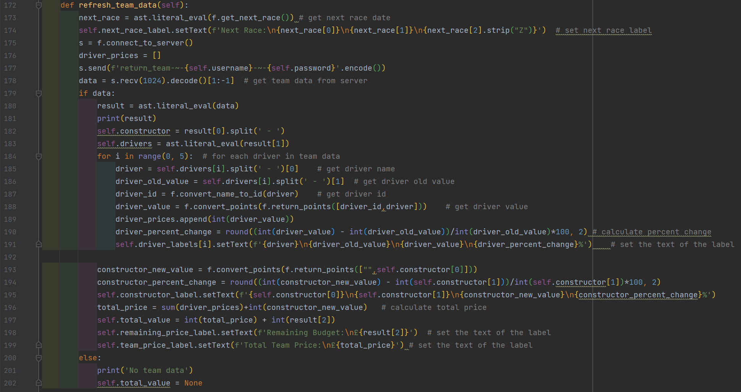

This code first runs the get next race function, then updates the next race label, with the given data.

The code then asks the server to return the team, which if there is data will get each driver’s name, the value at which the user picked them, the current value and the percentage change between each price, and then updates the corresponding label.

The code gets the current value of their constructor, the old value, and the percentage change and adds them to the constructor label. It then calculates the total value of the team and gets the remaining budget from the server and adds them to their corresponding labels.

But if no data is present when it is requested then it will just print “no team data” and set the total_value attribute to None.



Which is done so that when parsing the data to the edit team window it will not crash if the variable is not set. So, if it does have a true value it can use that to calculate how much total value they can allocate to the user otherwise it uses the base value of £100,000,000. 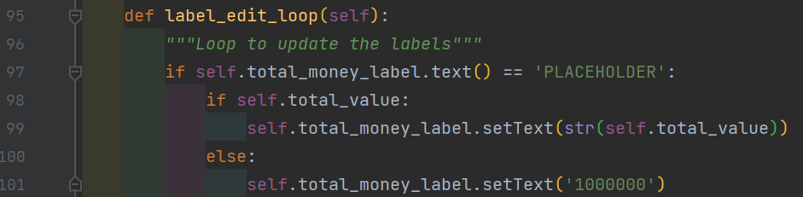So now the user will be able to gain or lose money depending on who they pick.

Now I need to create the get_next_race() function so the rest of my code can function. 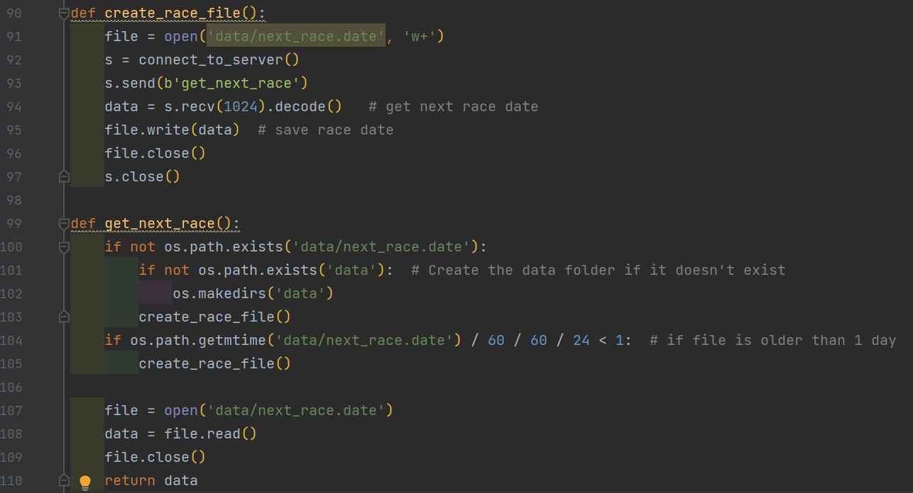

The get_next_race function is called at the start of the refresh data method, its purpose is just to return the date of the next race when requested. As this date is not going to change very often I made it check if the file was older than a day and if it was it would overwrite the file by requesting for the date again and saving it. To do this, I needed to create a new command on the server.

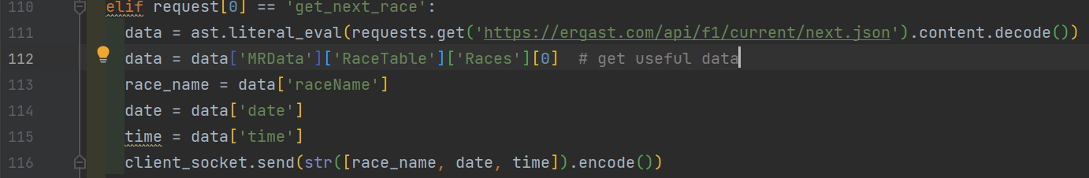

So now when a client requests the get next race command it gets the data from the api, which returns: 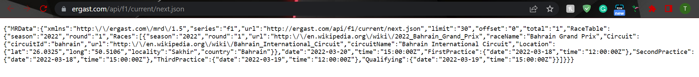This data is then processed to return the name of the next race, the date and time at which it will take place, and it then sends this data to the client.

### Development Testing

|  |  |  |
| --- | --- | --- |
| **Test Case** | **Pass / Fail** | **Comments** |
| Get the team data from the server | Pass |  |
| Update the correct labels | Pass |  |
| Link the refresh data button to the process | Pass |  |
| Show the price at which the user bought the driver and the current price | Pass |  |
| Show the percentage change of each driver in their team | Pass |  |
| Colour the label accordingly | Fail | It’s not clear how to change the colour of some of the text in a PyQt5 GUI label. |
| Get the next race information from the server and display it | Pass |  |

### Conclusion

This week completed the work on the Main menu, displaying the selected team using data from the server. I also added several usability features that will help keep players engaged with the progress of their team and the game, such as calculating the percentage change to the driver's scores.

I was not able to change the colour of the percentage change based on whether it’s positive or negative due to a lack of documentation on the topic, so I had no idea how to do this or whether it is possible. So, I decided to not pursue the idea for now and may implement it in the future.

## Week 15 – Error Handling

Last week I finished the main menu label edits and parsed and created support for holding the remaining money for each user. This fixed many issues and made my code closer to being finished, but also created a lot of places where the code can error, so this week I aim to prevent these errors or tell the user through the GUI that what they are doing is not supported.

To do this I need to:

* Find all the places in which the code crashes or behaves as not expected
* Find a fix or workaround
* Implement the fix
* Test each fix

The first error I found was when editing your team if you did not choose a driver or constructor then it would crash whenever you request the data from the server.

This was caused by it trying to split the points and driver/ constructor name and would get an index error. I decided to stop this by just checking if each of the combo boxes have valid data in them when the submit button is pressed.

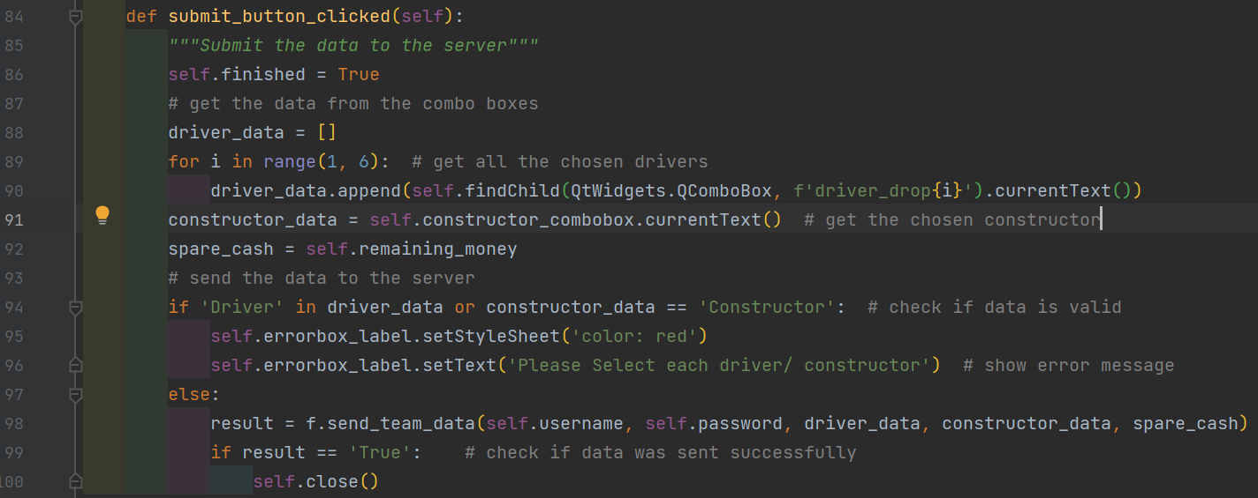

Now when the submit button is pressed, it will collect all the values from the combo box and if any of the boxes still have Driver or Constructor then it displays a red error message to tell the user to pick each driver and constructor. If all the drivers and constructors are chosen then proceed by sending the data to the server.

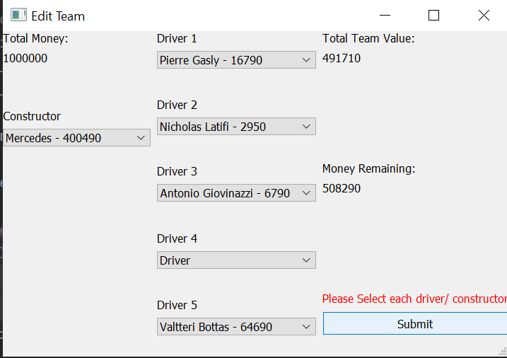

So now if you attempt to submit your incomplete team then it prompts with this red error message shown above.

I was testing my project and did not find any crashes or major bugs, so I decided to end this iteration of Error Handling early so that I can start on my client server chat.

### Development Testing

|  |  |  |
| --- | --- | --- |
| **Test Case** | **Pass / Fail** | **Comments** |
| Able to use to create and edit a team, refresh the scores without any code crashes or unexpected behaviour | Pass | Initial testing failed and the failing test case was added below.  Subsequent retesting after the fix passed. |
| Add validation that handles a team with a missing driver or constructor | Pass |  |

### Conclusion

In previous weeks I had focussed on developing new features and there was a risk if I continued without testing the now almost complete system that I would find lots of errors and not have time to fix all of the bugs.  
This interim testing round of the almost complete system first failed finding an urgent bug that needed to be fixed, but on retesting it passed giving much more confidence for the next weeks development of the chat room functionality.

## Week 16 – Chat Room Development

Last week I fixed an error which would cause unexpected crashes, and as no more errors could be found at this stage, I decided to move on to creating the chat room functionality.

To do this I need to:

* Open a new port on the server for the chat
* The server needs to receive get or send requests
* Store send requests so that it can reply to get requests
* Client needs to send a user input to the server
* Client code needs to be linked to the GUI
* The GUI needs to show the chats

To start with I realised I needed to edit the GUI slightly on the main menu window to add a submit button.

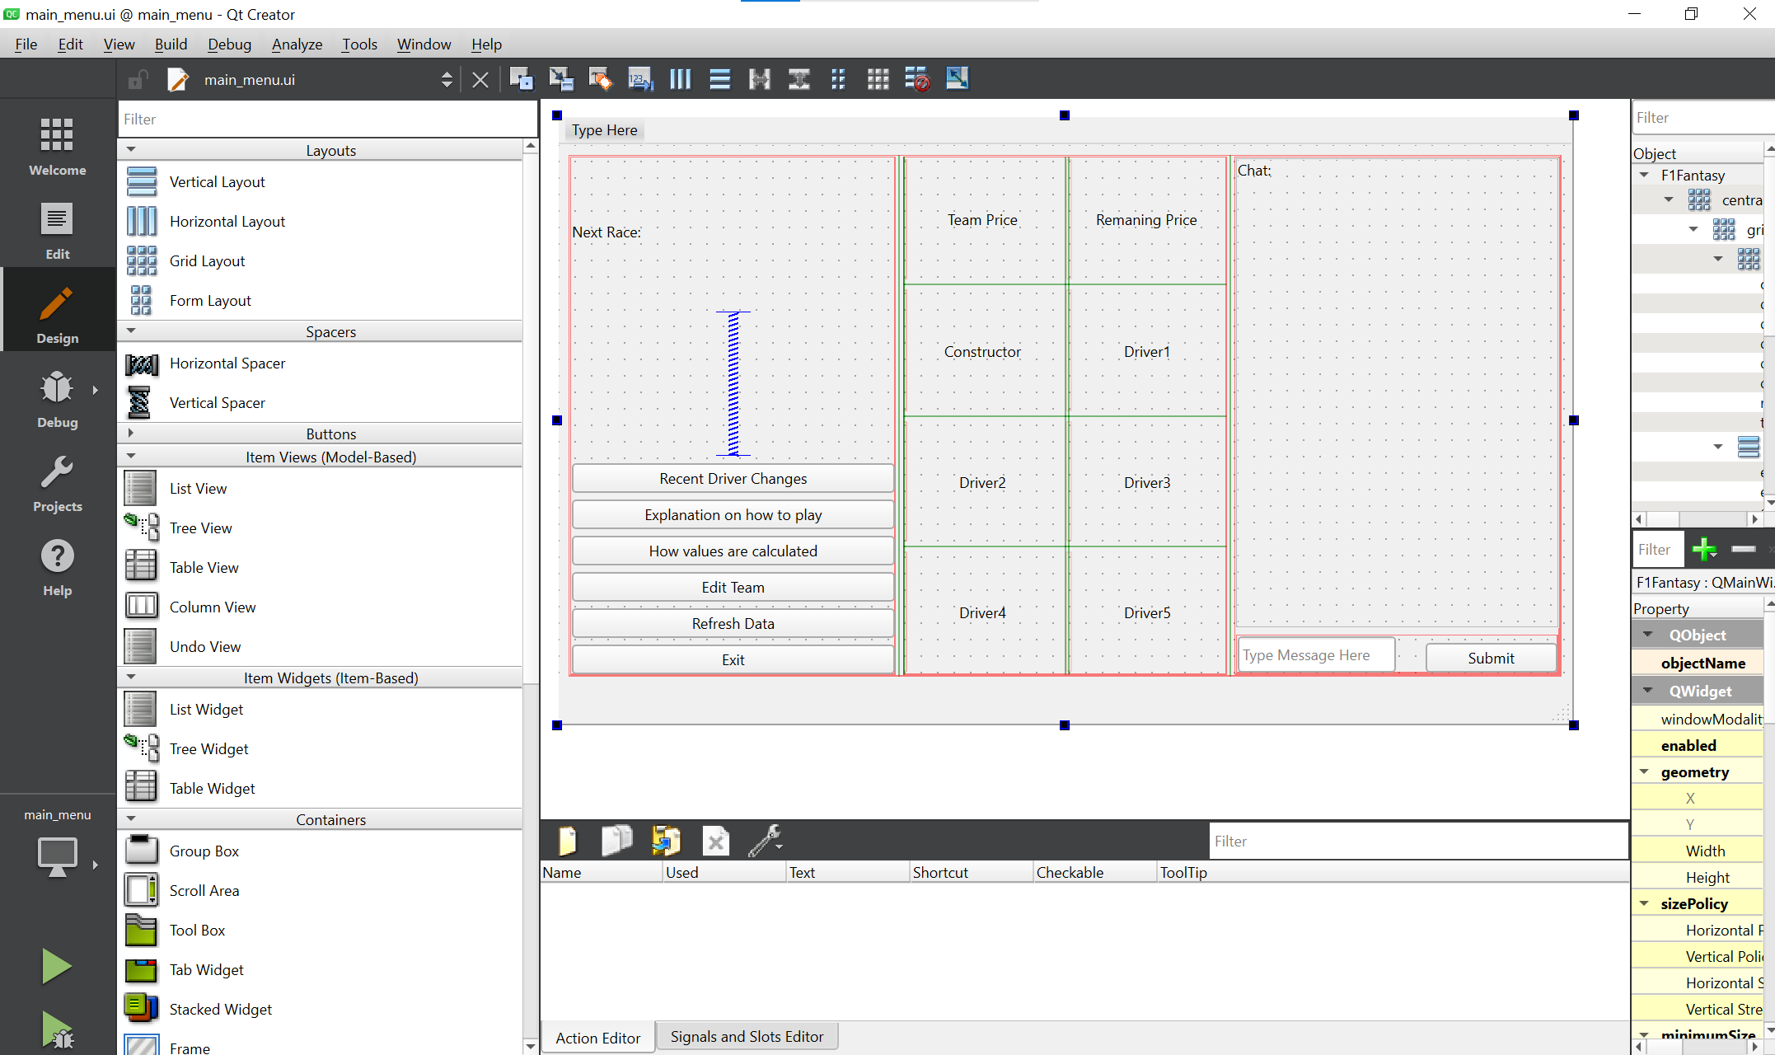

I added a submit button under the chat next to the input box, so that it can be used to send the messages.

I then had to find the chat elements in the code.

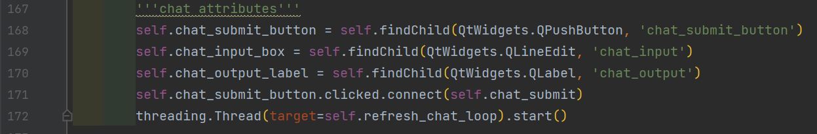This code just finds all the buttons and labels required to run the chat, it then sets it so when the submit button is pressed, the chat_submit method is called. It also starts a thread for the refresh chat loop so that it can run in parallel.

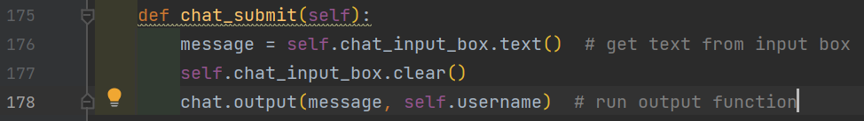

When the chat is submitted it runs this method, gets the message from the input box, clears it and passes the user’s username and the message to the output function.

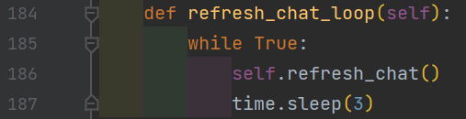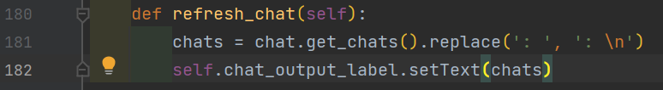When the refresh_chat_loop is run in parallel, it runs refresh_chat every 3 seconds, and refresh_chat gets the chats from the function get_chats and sets it as the chat text.

I decided to write the needed chat functions in a separate Python file and import them in.



This imports the chat.py Python file and sets it as chat so I can identify when it is being used.

Chat.py: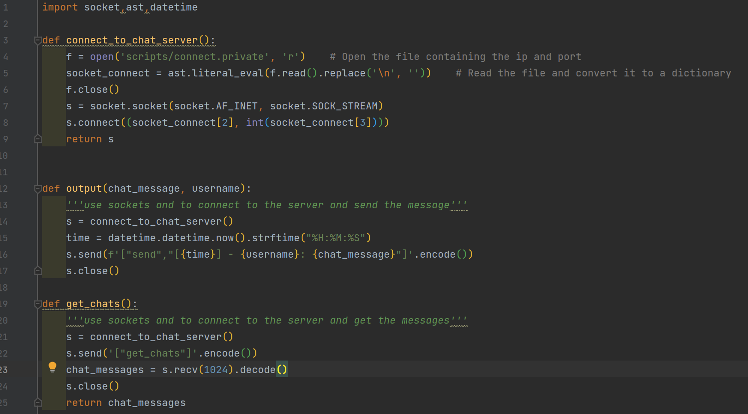The connect_to_chat server function opens the file that includes the required ip and port, and returns the socket connection.

The output function outputs the messages to the server. It connects to the server and sends the request and the message. The message would look like [time] – username: message. this means you know when the message was sent and by whom.

The get_chats function connects to the server and sends the “get_chats” request and then receives the response from the server and returns it.

Now I need to code the server to support the new port and new requests.

I decided to make this in a new Python script to not clutter the main.py, so I created chat_server.py.

chat_server.py:

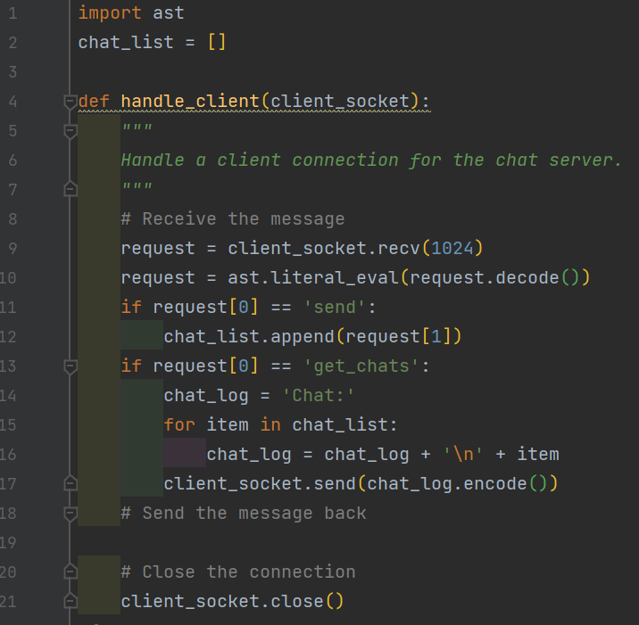

The handle_client function takes in the client socket, receives the request and decodes it. It then checks what the request is. If the request is “send” the function saves the message to chat_list, and if the request is “get_chats” then it creates a string that starts with chat: and adds each message then sends that to the client. When it is finished it closes the connection.

Now I need it to run in parallel with the main server code.

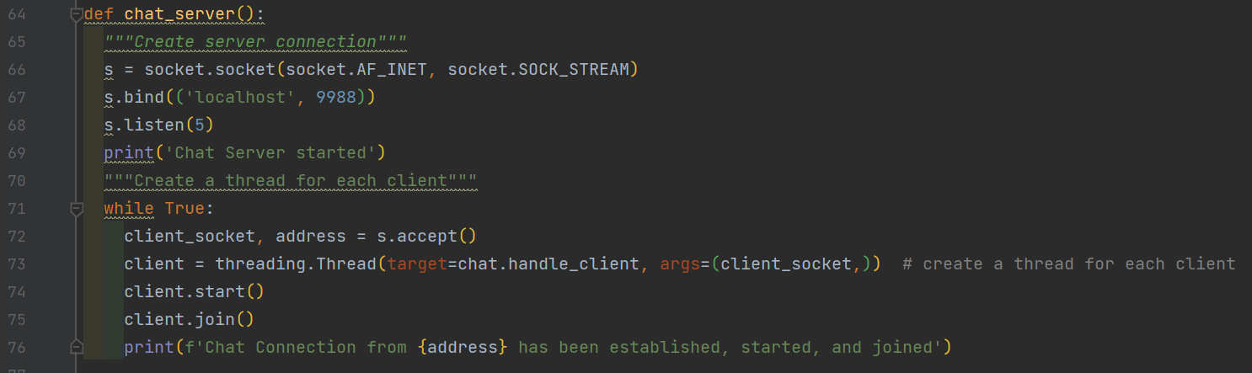

The chat server function just binds to the required port and ip waits for any connections and if a client connects it creates a thread for each client that runs the handle client function.

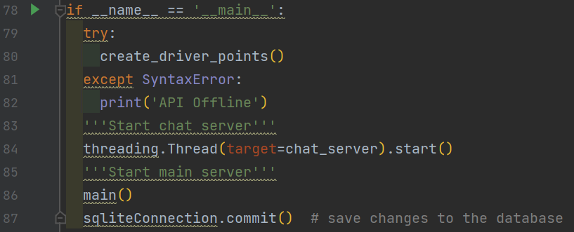

So now when the server code is run it runs the chat server function as a thread so it can run in parallel.

I have now finished the chat code and it works, it works how you would expect, and runs pretty smoothly.

When a message is sent it is displayed as such:

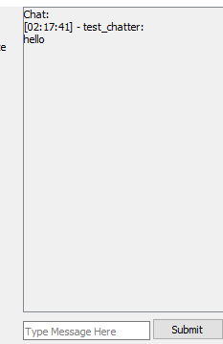

### Development Testing

|  |  |  |
| --- | --- | --- |
| **Test Case** | **Pass / Fail** | **Comments** |
| Open a new port on the server for the chat | Pass |  |
| The server needs to receive get or send requests | Pass |  |
| Store send requests so that it can reply to get requests | Pass |  |
| Client needs to send a user input to the server | Pass |  |
| Client code needs to be linked to the GUI | Pass |  |
| The GUI needs to show the chats | Pass |  |

### Conclusion

Adding chat room functionality within one week was ambitious and looking back it would have been good to address this earlier as it was a “Must have” priority.  However, the experience I gained earlier with communicating over sockets, threading and PyQt allowed me to apply what I learned earlier to develop this functionality within just one week.

# Evaluation Testing

After I completed development, I performed a complete system test of all of the functionality using the test cases that had been written during some of the earlier weeks of development, but I also wrote several new test cases to cover areas where the whole system was not available when the functionality was initially developed. These tests check both normal expected usage, expected cases that should fail and unexpected input from users.

I also recorded myself testing and running the program and using it as intended.



## Point Tests

|  |  |  |  |  |  |
| --- | --- | --- | --- | --- | --- |
| Test No | Test | Input | Expected Output | Actual Output | Video/ Photo Reference |
| P1 | Driver Points | Check the points of driver ‘Sebastian Vettel’ | 5244 | 5244 |  |
| P2 | Drivers points | Check the points of driver ‘Daniel Riccardo’ | 2745 | 2745 |  |
| P3 | Constructor Points | Check the points of constructor ‘Aston Martin’ | 813 | 813 |  |

## API Tests

|  |  |  |  |  |  |
| --- | --- | --- | --- | --- | --- |
| Test No | Test | Input | Expected Output | Actual Output | Video/ Photo Reference |
| A1 | Correct info from API checked against info stored | Check raw data file for 2015 round 5, ‘Lewis Hamilton’ and ‘Nico Rosberg’ where in the same team | Both drivers where at Mercedes | Both drivers where at Mercedes |  |
| A2 | Correct race info | Check race name of 2019 5th round | Spanish Grand Prix | Spanish Grand Prix |  |

## Login Tests

|  |  |  |  |  |  |
| --- | --- | --- | --- | --- | --- |
| Test No | Test | Input | Expected Output | Actual Output | Video/ Photo Reference |
| L1 | Login | Username = test  Password = test | True | True |  |
| L2 | Login | Username = test9  Password = test | False | False |  |
| L3 | Login | Username = test  Password = test9 | False | False |  |
| L4 | Register | Username = test  Password = test | False | False |  |
| L5 | Register | Username = test5  Password = test | True | True |  |
| L6 | Register, then login | Username = testing  Password = test | True, then True | True, then True |  |

## Main Menu Tests

|  |  |  |  |  |  |
| --- | --- | --- | --- | --- | --- |
| Test No | Test | Input | Expected Output | Actual Output | Video/ Photo Reference |
| M1 | Main menu | Login | The main menu GUI to open | True |  |
| M2 | How to Play | Press how to play button | The How to play dialog box to open | True |  |
| M3 | How to Play Ok button | Press Ok Button | Close the dialog box | True |  |
| M4 | Points Value Calculation Box | Press how points values are calculated button | The Points value calculation dialog box to open | True |  |
| M5 | Points Value Calculation ok button | Press Ok Button | Close the dialog box | True |  |

## Edit Team Menu Tests

|  |  |  |  |  |  |
| --- | --- | --- | --- | --- | --- |
| Test No | Test | Input | Expected Output | Actual Output | Video/ Photo Reference |
| E1 | Empty fields | Select none of the drivers or constructors and press submit | Error message displayed | Error message displayed |  |
| E2 | Half empty fields | Select half of the drivers and select the constructor and leave the other half, then press submit | Error message displayed | Error message displayed |  |
| E3 | no empty fields | Select data for all combo boxes and press submit | Window closes | Window closes |  |
| E4 | Duplicate drivers | Select two of the same drivers | Error message displayed | Window closes and program continues |  |

## Points to Money Conversion Tests

|  |  |  |  |  |  |
| --- | --- | --- | --- | --- | --- |
| Test No | Test | Input | Expected Output | Actual Output | Video/ Photo Reference |
| O1 | Money conversion for ‘Daniel Riccardo’ | 2745*20+250=55150 | 55150 | 55150 |  |
| O2 | Money conversion for ‘Mercedes’ | 21492*20+250=430090 | 430090 | 430090 |  |

## Next Race Tests

|  |  |  |  |  |  |
| --- | --- | --- | --- | --- | --- |
| Test No | Test | Input | Expected Output | Actual Output | Video/ Photo Reference |
| N1 | Correct race | Check next race name and time on 15/03/2022 | Saudi Arabia, 27/03/2022 at 17:00 | Saudi Arabia, 27/03/2022 at 17:00 |  |
| N2 | Correct race | Check next race name and time on 03/04/2022 | Australia, 10/04/2022 at 5:00 | Australia, 10/04/2022 at 5:00 |  |

## Hashing Tests

|  |  |  |  |  |  |
| --- | --- | --- | --- | --- | --- |
| Test No | Test | Input | Expected Output | Actual Output | Video/ Photo Reference |
| H1 | Password hash check | Create a new account with username = hash  Password = pass | check the database and see if the password is stored | Password is not stored |  |
| H2 | Database check | Check the login table for any non hashed passwords | No Non-hashed passwords | No Non-hashed passwords |  |

## Chatroom Tests

|  |  |  |  |  |  |
| --- | --- | --- | --- | --- | --- |
| Test No | Test | Input | Expected Output | Actual Output | Video/ Photo Reference |
| C1 | Sending and viewing a message | “Hello world” | Hello world to show in chat | Hello world was shown in chat |  |
| C2 | Sending special characters | “hi, #$%@+” | “hi, #$%@+” | “hi, #$%@+” |  |
| C3 | Viewing a message on a different client | “Hello world” sent from one client, then the other sends “hi” back | Messages on both clients | Both messages visible on both clients |  |

## Usability Testing

To test my project was easy to use and the requirement that it was easy to navigate was successfully implemented, I asked a stakeholder who had not previously used the system to:

* Create an account and log in
* Create a team
* Refresh their team data
* Send a message using the chat system

While they used the system I asked them to speak out their thoughts about the useability of the system, and how easy they found doing the actions were. I captured the feedback here:

* “The login screen is like other programs, so I know how to navigate through it”
* “Very simple to create a new account”
* “I’m not sure how I would change my password if I needed to”
* “It was good to see how much money I had left as I added drivers to my team”
* “As there was no order to the list of drivers it was hard to find Daniel Riccardo”
* “Easy to tell how to refresh my team”
* “It was easy to know where to go for each of the features, because the button names made sense”
* “The chat looks normal and works well”
* “I noticed you can’t press enter to send the message, but pressing the submit button works fine”
* “It would be nice if I could send some emojis”

Overall, the stakeholder liked my project and they mentioned how easy the GUI was to navigate. They noticed there was no ‘forgot password’ button. They said creating their team was easy but found it slightly annoying to find the driver they wanted in the list as it is not ordered. They liked the chat and how it looked but noticed that if you press enter it does not send the message like many other chats do, and that they couldn’t use any emojis. Many of these issues can be solved easily in the future and have been added to the “Future of my program” section below.

# Evaluation

## Required Features Evaluation

This table evaluates each of Required Features, cross referencing them with the tests that ensured were performed in the Testing Section above.

|  |  |  |  |
| --- | --- | --- | --- |
| Priority | Feature | Met / Not Met | Tested by Test No |
| M | A client-server chatroom | Met | Usability Testing, C1, C2, C3 |
| M | Web scraping/API usage to get the race results and driver data needed. | Met | A1, A2 |
| M | A scoring system that analyses the data from races, to give each driver a point score. | Met | P1, P2, P3 |
| M | A price algorithm that converts points into cash. | Met | O1, O2 |
| M | Get the next race information and when it occurs and display it, to keep users engaged with the system. | Met | N1, N2 |
| M | A login system so that user’s data can be transferred to different machines, and so users only get to see their own data. | Met | L1, L2, L3, L4, L5 |
| M | An interface to allow the user to edit and display their team | Met | E1, E2, E3, E4 |
| S | A good-looking GUI to show all the data needed and provide a way around the program | Met | Usability testing |
| S | Password Hashing so no passwords are stored in databases, limiting the effect of any data breaches. | Met | H1, H2 |
| C | Encryption of data that is sent between the server and clients to prevent man in the middle attacks. | Not Met, due to time constraints | N/A |
| W | Introduce complicated animated graphics, this is beyond what is achievable during this MVP, but is recorded here for future development. | Not Met, but this was not planned to be implemented in this project, and only recorded for future developments | N/A |

## Stakeholder feedback

Following the directed usability testing I gave my project to my stakeholders and asked for any feedback. I listed their responses and an explanation attached.

**James** – “I wish the program menus looked a bit better, but I was able to navigate through it well”

The benefit of my code using .ui files for my GUI is that I can just switch out the file and change the GUI without any change to the code. This means in the future it will be very easy to create a nicer looking user interface.

**Chris** – “The amount each driver was worth seems a bit skewed, as there is a large difference in prices”

Due to the code being heavily biased in favour of drivers that have been driving for longer, as it is all based on the amount of races. However this can be changed with tweaks to the points distribution, meaning you do not need to change any of the code.

**Sam** – “I actually like the fantasy f1, but I wasn't able to include all my favourite drivers as they cost too much“

This is good as it shows the stakeholders are invested in the product and this stops anyone building a team of all the top drivers.

This feedback from my stakeholders can be used to improve the program in the future and shows that we meet the requirements set to begin with.

## Maintainability and Future of program

I have made the code with lots of comments and spacing to make the code easy to follow by anyone with a decent understanding of Python. As well as commenting within the code I have also named my variables well to ensure it is easy to understand what each variable is intended for without having to search out its meaning within the code.

Throughout the development of the code I committed it regularly to GitHub, so if anyone wanted to know how it was coded, or how the code evolved over time they could check the commit history. GitHub also provides great tools to allow others to clone the code and either develop it themselves or make contributions back to my repository as pull requests.

The design of the code separates the client and the server components, which greatly simplifies what each aspect of the code deals with, making it both easier to understand, test and modify in the future. The client focuses on the Graphical user interface and communicating with the server. While the server handles the more complicated scoring logic, gathering data from other APIs, storing of the user’s data, and communication between users.

### Dependencies and Dependency Management

Using external libraries and the Qt framework gave me a great improvement in development speed and allowed this project to be attempted, which would otherwise not be possible for a single person. However, it is important to remember that the libraries and frameworks I have used will continue to change, and need to be updated to support bug and security fixes as well as new features. I could stick with the same versions of the modules forever, but that will miss out on any important fixes and older versions may not be supported on newer operating systems. That means that some effort will be needed in the future to update those libraries and handle any incompatibility between versions.

The code uses the following modules and libraries:

* Python Standard Library (v3.8)
  + requests
  + queue
  + datetime
  + os
  + socket
  + ast
  + time
  + threading
  + sqllite3
  + json
* PyQt5
  + QtGui
  + QtWidgets
  + uic
* argon2
  + PasswordHasher

As well as dependencies used within the code this project depends on the source of data to be able to gather race results and the next race information. Should this stop functioning then an alternative would need to be found, and adapter code written if the data formats were different. This code depends on the [Ergast Developer API](http://ergast.com/mrd/).

### Future of my program

In the future I would like to work on the GUI and it more appealing to use. I have also been thinking I may convert the Python program into a website, this would mean it would be very easy to access for users and would help broaden my audience. I would also like to work on the points system to make it more balanced.

I have listed all the mentioned issues or missed features that will be fixed/ added in the future:

|  |  |  |
| --- | --- | --- |
| Future Improvement | Source | Comment |
| Encryption of data that is sent between the server and clients to prevent man in the middle attacks | Required Features | This was a ‘Could-have’ requirement, challenges during development with chunking the data into set sizes made this too difficult to fit into this project but could be implemented later. |
| Introduce complicated animated graphics and more engaging visuals | Required Features | This was a ‘Won’t-have’ requirement, but the addition of animation, videos, driver pictures and constructor logos would improve the user interface. |
| Add a Profanity filter to the chat system to protect young users | Stakeholders | This was listed when considering the stakeholders, but there was not enough time to implement it. There are existing profanity filter modules for python that could be considered such as profanity-filter |
| Allow public use of the system over the internet | Hardware Requirements | This would open up the system to many more users, but you would need to reconsider the server hardware, possibly using AWS or other cloud services, and the security aspects of a public internet service. |
| Recent Driver Changes | GUI Design | This additional screen shows the recent value changes for drivers and constructors, but there was not enough time to fully implement it |
| Add colouring to the diver value change labels | Development Week 14 | This was an optional task that was harder to implement than anticipated, My research into the topic has come back unsuccessful. |
| Add Change password support | Usability testing | Over time users will need to change or forget their passwords, the system needs to be able to handle both of these issues. |
| Order the Drivers in the combo box lists | Usability testing | This will make it easier to find specific people |
| Submit chat message on enter | Usability testing | This would be a simple addition to respond to the enter keypress on the chat message input box |
| Emoji support in the chat | Usability testing | Adding emojis would improve the social aspects of the chat, particularly given the target stakeholder age group. |
| Improve the visual appearance of the menus | Stakeholder Feedback | The increased use of images and colour could be added to the UI files later to improve this. |
| Improve balancing of the driver pricing | Stakeholder feedback | Currently the pricing being is biased towards drivers that have been driving for longer. This can be changed with tweaks to the points distribution, meaning you do not need to change any of the code. I will need to trial a few different approaches to the points distribution to find one that provides better balance. |

## Overall Evaluation

My project was more complex than I initially considered, the in-depth points scoring system and the volume of the race data, together with the challenges of implementing a client-server system communicating via sockets in Python and making use of multithreaded programming made this a challenging project.

I tackled the initial complexity by breaking down my project into smaller components that could be more easily understood and planned. Before I started my research, I did not know how to solve some of the problems my project faced, but a mixture of research and demo implementations helped find solutions to the trickier challenges.

Prioritising the requirements using MoSCoW prioritisation allowed me to focus on what was needed and most important for my project to deliver to meet the success criteria. Considering the system as a whole was important to ensure that the individual components would combine effectively in the system. Detailed designs in the more complex areas such as the user interface were helpful in directing the development and ensuring that the vital aspects were considered early.

Throughout my project I have learnt lots of new skills such as:

* Creating and implementing a Python GUI.
* Creating and managing an SQL Database.
* Using a Hashing algorithm to protect user’s passwords.
* Use of multithreading to increase performance, and debugging race conditions.
* Getting required data from an API and working with large datasets.
* Client-Server communication using sockets.

These skills learnt at the start of my code helped me code the later stages of my program faster using the experience I had gained earlier.

This was my first experience of iterative development on a project, I found the weekly iteration process helped keep me on track using the prioritised requirements list together with the weekly assessment of my progress. My use of GitHub helped me a few times when I found myself in a dead end and needed to step back to an earlier stage in the code.

In this project I applied multiple approaches to testing with weekly testing of the development iteration, whole system testing at the end of development and usability testing focusing on the experience of a potential user. These different approaches to testing were good as they required different ways of thinking and helped identify any issues with my code or areas for future development.

Based on the cross-reference table in the evaluation section (above), where I cross referenced the requirement against the tests that proved the requirements were implemented, all the ‘Must have’ and ‘Should have’ requirements were fully implemented. Therefore, my project has exceeded the success criteria of the MVP and has gone further to implement the ‘Should have’ components as well. We did not have time to implement the ‘Could have’ requirement and this has been transferred to the future of my program section above, together with the ‘Won’t have’ requirement.

There were some new features raised as part of the useability testing and stakeholder feedback, that have also been added to the future of my program. The requirement that the system needs to have “A good-looking GUI to show all the data needed and provide a way around the program” was very vague and hard to test, the only suitable way was feedback from the useability testing, the majority of feedback showed that it was acceptable but there were areas that could be improved. For this MVP I treated this as a pass for my requirement, but in the future I would try to define a requirement that is more specific and easier to test.

Throughout this project I have applied more programming, design and testing skills and approached the issue in a more organised and planned way than in previous work. I have learnt a lot through researching, designing and testing this system especially considering the useability testing and the user experience. I have also learnt a lot of technical skills through threading and communication as well as working with databases and working with a responsive user interface. I am pleased to see the project was a success, and I have many ongoing plans (details in the future of my program section) to improve the system and take it further.

# Final Code

## Client

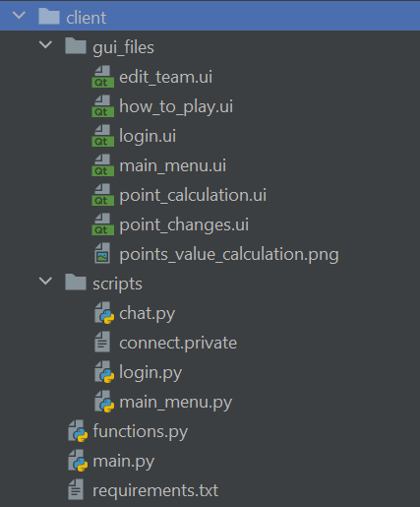

### main.py

from scripts import login as lg  
from scripts import main_menu as mm  
def main*()*:  
 result = lg.login*()* # get login result  
 if result:  
 print*(*'logged in'*)* mm.main*(*result*)* # call main menu  
  
if __name__ == '__main__':  
 main*()*

### functions.py

import datetime  
import os,socket, ast  
  
  
def connect_to_server*()*:  
 f = open*(*'scripts/connect.private', 'r'*)* # Open the file containing the ip and port  
 socket_connect = ast.literal_eval*(*f.read*()*.replace*(*'\n', ''*))* # Read the file and convert it to a dictionary  
 f.close*()* s = socket.socket*(*socket.AF_INET, socket.SOCK_STREAM*)* s.connect*((*socket_connect*[*0*]*, int*(*socket_connect*[*1*])))* return s  
  
  
def create_driver_file*()*:  
 # Get data from server and Create the file containing the drivers and constructors  
 s = connect_to_server*()* s.send*(*b'return_current_driver_and_constructors'*)* data = ast.literal_eval*(*s.recv*(*10028*)*.decode*())* f = open*(*'data/current_drivers_and_constructors.json', 'w+'*)* f.write*(*str*(*data*))* f.close*()*def return_current_drivers_and_constructors*()*:  
 if not os.path.exists*(*'data/current_drivers_and_constructors.json'*)*:  
 if not os.path.exists*(*'data'*)*: # Create the data folder if it doesn't exist  
 os.makedirs*(*'data'*)* create_driver_file*()* if os.path.getmtime*(*'data/current_drivers_and_constructors.json'*)*/60/60/24 < 1: # if the file is older than 1 day  
 create_driver_file*()* f = open*(*'data/current_drivers_and_constructors.json', 'r'*)* data = f.read*()* # get data from file  
 if data == '[]' or data == None:  
 f.close*()* create_driver_file*()* f = open*(*'data/current_drivers_and_constructors.json', 'r'*)* f.close*()* return ast.literal_eval*(*data*)*def create_points_file*()*:  
 # Get data from server and create the file containing the point data  
 f = open*(*'data/points.json', 'w+'*)* s = connect_to_server*()* s.send*(*b'return_point_data'*)* point_data = s.recv*(*100080*)*.decode*()* f.write*(*f'["*{*datetime.date.today*()}*",*{*point_data*}*]'*)* f.close*()*def return_points*(*driver*)*:  
 if not os.path.exists*(*'data/points.json'*)*:  
 if not os.path.exists*(*'data'*)*:  
 os.makedirs*(*'data'*)* create_points_file*()* f = open*(*'data/points.json'*)* data = ast.literal_eval*(*f.read*())* if data*[*0*]* != str*(*datetime.date.today*())* or data*[*1*]* == '[]': # if the file is older than 1 day or empty  
 f.close*()* create_points_file*()* f.close*()* try:  
 return data*[*1*][*1*][*driver*[*0*]]* # try driver in driver list  
 except KeyError:  
 try:  
 return data*[*1*][*0*][*driver*[*1*]]* # try constructor in constructor list  
 except KeyError:  
 print*(*driver, 'Driver/ Constructor not in point data'*)*def send_team_data*(*username, password, driver_data, constructor_data, spare_cash*)*:  
 s = connect_to_server*()* s.send*(*f'save_team-~-*{*username*}*-~-*{*password*}*-~-*{*constructor_data*}*-~-*{*driver_data*}*-~-*{*spare_cash*}*'.encode*())* result = s.recv*(*1024*)*.decode*()* return result  
  
def convert_name_to_id*(*name*)*:  
 *'''use the current_drivers_and_constructors.json file to convert the name[1] to the id[0]'''* data = return_current_drivers_and_constructors*()* for driver in ast.literal_eval*(*data*[*0*])*:  
 if driver*[*1*]* == name:  
 return driver*[*0*]* for constructor in ast.literal_eval*(*data*[*1*])*:  
 if constructor*[*1*]* == name:  
 return constructor*[*0*]*def convert_points*(*points*)*:  
 return str*(*250 + int*(*points*)*\*20*)*def create_race_file*()*:  
 file = open*(*'data/next_race.date', 'w+'*)* s = connect_to_server*()* s.send*(*b'get_next_race'*)* data = s.recv*(*1024*)*.decode*()* # get next race date  
 file.write*(*data*)* # save race date  
 file.close*()* s.close*()*def get_next_race*()*:  
 if not os.path.exists*(*'data/next_race.date'*)*:  
 if not os.path.exists*(*'data'*)*: # Create the data folder if it doesn't exist  
 os.makedirs*(*'data'*)* create_race_file*()* if os.path.getmtime*(*'data/next_race.date'*)* / 60 / 60 / 24 < 1: # if file is older than 1 day  
 create_race_file*()* file = open*(*'data/next_race.date'*)* data = file.read*()* if data == "['N', '/', 'A']": # if no data saved, request again  
 create_race_file*()* file = open*(*'data/next_race.date'*)* data = file.read*()* file.close*()* return data

### scripts/login.py

import ast  
import sys  
import functions as f  
from PyQt5 import QtWidgets, uic  
  
class LoginUser:  
 def __init__*(*self, username, password*)*:  
 self.username = username  
 self.password = password  
  
 def get_username*(*self*)*:  
 return self.username  
  
 def get_password*(*self*)*:  
 return self.password  
  
class Ui*(*QtWidgets.QMainWindow*)*:  
 def __init__*(*self*)*:  
 super*(*Ui, self*)*.__init__*()* # Call the inherited classes __init__ method  
 uic.loadUi*(*'gui_files/login.ui', self*)* # Load the .ui file  
 self.show*()* # Show the GUI  
 self.logged_in = False # Set logged_in to False  
 self.logged_in_user = None  
  
 """Find all Login Widgets"""  
 self.login_button = self.findChild*(*QtWidgets.QPushButton, 'login_button'*)* self.login_username = self.findChild*(*QtWidgets.QLineEdit, 'login_username'*)* self.login_password = self.findChild*(*QtWidgets.QLineEdit, 'login_password'*)* self.login_errorbox = self.findChild*(*QtWidgets.QLabel, 'login_errorbox'*)* self.login_errorbox.setStyleSheet*(*'color: red'*)* # Set the errorbox to red  
 self.login_button.clicked.connect*(*self.login_button_pressed*)* # On click, call the login_button_pressed function  
  
 """Find all Register Widgets"""  
 self.register_button = self.findChild*(*QtWidgets.QPushButton, 'register_button'*)* self.register_username = self.findChild*(*QtWidgets.QLineEdit, 'register_username'*)* self.register_password = self.findChild*(*QtWidgets.QLineEdit, 'register_password'*)* self.register_errorbox = self.findChild*(*QtWidgets.QLabel, 'register_errorbox'*)* self.register_errorbox.setStyleSheet*(*'color: red'*)* # Set the errorbox to red  
 self.register_button.clicked.connect*(*self.register_button_pressed*)* # On click, call register_button_pressed  
  
 def login_button_pressed*(*self*)*:  
 *"""Check if server is online"""* try:  
 s = f.connect_to_server*()* except Exception:  
 self.login_errorbox.setText*(*'Could not connect to server'*)* return  
  
 username = self.login_username.text*()* # Get the username from the login_username widget  
 password = self.login_password.text*()* # Get the password from the login_password widget  
 s.send*(*f'login-~-*{*username*}*-~-*{*password*}*'.encode*())* result = str*(*s.recv*(*1024*)*.decode*())* # Get the result from the server  
 if result == 'True':  
 print*(*'Login successful'*)* self.logged_in = True  
 self.logged_in_user = LoginUser*(*username, password*)* self.close*()* # If Login successful close the login window  
 elif not ast.literal_eval*(*result*)[*0*]*:  
 self.login_errorbox.setText*(*'Username or password incorrect'*)* else:  
 self.login_errorbox.setText*(*'Login failed'*)* # If Login failed show error message  
 s.close*()* def register_button_pressed*(*self*)*:  
 *"""Check if server is online"""* try:  
 s = f.connect_to_server*()* except Exception:  
 self.register_errorbox.setText*(*'Could not connect to server'*)* return  
  
 username = self.register_username.text*()* # Get the username from the register_username widget  
 password = self.register_password.text*()* # Get the password from the register_password widget  
  
  
 if '-~-' in *(*username or password*)*:  
 self.register_errorbox.setText*(*'-~- Cannot be used'*)* return  
   
 print*(*f'Register pressed: Username - *{*username*}*, Password - *{*password*}*'*)* s.send*(*f'register-~-*{*username*}*-~-*{*password*}*'.encode*())* result = s.recv*(*1024*)*.decode*()* # Get the result from the server  
 print*(*result*)* if str*(*result*)* == 'True': # If the register is True  
 print*(*'Register successful'*)* self.register_errorbox.setStyleSheet*(*'color: green'*)* # Set the errorbox colour to green  
 self.register_errorbox.setText*(*'Register successful'*)* # Show the register successful message  
 elif not ast.literal_eval*(*result*)[*0*]*:  
 self.register_errorbox.setText*(*'Username already exists'*)* # If the username already exists  
 else:  
 self.register_errorbox.setText*(*'Register failed'*)* # If register is False, show error message  
  
 def get_logged_in*(*self*)*:  
 *"""Get the logged_in value"""* return self.logged_in  
  
 def get_logged_in_user*(*self*)*:  
 *"""Get the logged_in_user value"""* return self.logged_in_user  
  
def login*()*:  
 app = QtWidgets.QApplication*(*sys.argv*)* # Create an instance of QtWidgets.QApplication  
 window = Ui*()* # Create an instance of our class  
 app.exec_*()* # Start the application  
 if window.get_logged_in*()*: # Return the logged_in value  
 return window.get_logged_in_user*()* else:  
 print*(*'Login failed'*)*

### scripts/main_menu.py

from PyQt5 import QtWidgets, uic  
from PyQt5.QtGui import QIcon, QPixmap  
import sys  
import ast  
import time  
import threading  
import functions as f  
from scripts.login import LoginUser  
import scripts.chat as chat  
  
class Recent_Point_Changes*(*QtWidgets.QDialog*)*:  
 *"""Display the point changes dialog box"""* def __init__*(*self*)*:  
 super*(*Recent_Point_Changes, self*)*.__init__*()* uic.loadUi*(*'gui_files/point_changes.ui', self*)* self.setWindowTitle*(*'Recent Driver and Constructor Point Changes'*)* # set title  
 self.show*()* self.ok_button = self.findChild*(*QtWidgets.QPushButton, 'ok_button'*)* self.ok_button.clicked.connect*(*self.close*)* # close dialogue box when ok is clicked  
  
class HTP_Dialogue_Box*(*QtWidgets.QDialog*)*:  
 *"""Display the how to play dialog box"""* def __init__*(*self*)*:  
 super*(*HTP_Dialogue_Box, self*)*.__init__*()* uic.loadUi*(*'gui_files/how_to_play.ui', self*)* self.setWindowTitle*(*'How to Play'*)* # set title  
 self.show*()* self.ok_button = self.findChild*(*QtWidgets.QPushButton, 'ok_button'*)* self.ok_button.clicked.connect*(*self.close*)* # close dialogue box when ok is clicked  
  
class Point_Calculation_Dialogue_Box*(*QtWidgets.QDialog*)*:  
 *"""Display the point calculation dialogue box"""* def __init__*(*self*)*:  
 super*(*Point_Calculation_Dialogue_Box, self*)*.__init__*()* uic.loadUi*(*'gui_files/point_calculation.ui', self*)* self.setWindowTitle*(*'Point Calculation'*)* # set title  
 label = self.findChild*(*QtWidgets.QLabel, 'point_calculation_pixelmap'*)* pixmap = QPixmap*(*'gui_files/points_value_calculation.png'*)* label.setPixmap*(*pixmap*)* self.show*()* self.ok_button = self.findChild*(*QtWidgets.QPushButton, 'ok_button'*)* self.ok_button.clicked.connect*(*self.close*)* # close dialogue box when ok is clicked  
  
class Edit_Team*(*QtWidgets.QMainWindow*)*:  
 def __init__*(*self, username, password, total_value*)*:  
 super*(*Edit_Team, self*)*.__init__*()* uic.loadUi*(*'gui_files/edit_team.ui', self*)* self.username = username  
 self.password = password  
 self.total_value = total_value  
 self.finished = False  
 self.setWindowTitle*(*'Edit Team'*)* # set title  
 '''find combo boxes and buttons'''  
 self.constructor_combobox = self.findChild*(*QtWidgets.QComboBox, 'constructor_drop'*)* self.submit_button = self.findChild*(*QtWidgets.QPushButton, 'submit_button'*)* self.total_team_value_label = self.findChild*(*QtWidgets.QLabel, 'total_team_value'*)* self.remaining_money_label = self.findChild*(*QtWidgets.QLabel, 'remaining_money'*)* self.total_money_label = self.findChild*(*QtWidgets.QLabel, 'total_money'*)* self.errorbox_label = self.findChild*(*QtWidgets.QLabel, 'errorbox'*)* self.set_combo_box_data*()* # set driver and constructor combobox items  
 self.submit_button.clicked.connect*(*self.submit_button_clicked*)* threading.Thread*(*target=self.label_edit_loop*)*.start*()* self.show*()* def set_combo_box_data*(*self*)*:  
 *"""Set the data for the combo box"""* data = f.return_current_drivers_and_constructors*()* # get data from server in form [[driver1,driver2],[team1,team2]]  
 drivers = data*[*0*]* constructors = data*[*1*]* # loop through the driver combo boxes  
 for i in range*(*1, 6*)*:  
 self.driver_combo_box = self.findChild*(*QtWidgets.QComboBox, f'driver_drop*{*i*}*'*)* for driver in ast.literal_eval*(*drivers*)*:  
 self.driver_combo_box.addItem*(*f'*{*driver*[*1*]}* - *{*f.convert_points*(*f.return_points*(*driver*))}*'*)* # add each driver and their points to the combo box  
 for constructor in ast.literal_eval*(*constructors*)*:  
 self.constructor_combobox.addItem*(*f'*{*constructor*[*1*]}* - *{*f.convert_points*(*f.return_points*(*constructor*))}*'*)* def submit_button_clicked*(*self*)*:  
 *"""Submit the data to the server"""* self.finished = True  
 # get the data from the combo boxes  
 driver_data = *[]* for i in range*(*1, 6*)*: # get all the chosen drivers  
 driver_data.append*(*self.findChild*(*QtWidgets.QComboBox, f'driver_drop*{*i*}*'*)*.currentText*())* constructor_data = self.constructor_combobox.currentText*()* # get the chosen constructor  
 spare_cash = self.remaining_money  
 # send the data to the server  
 if 'Driver' in driver_data or constructor_data == 'Constructor': # check if data is valid  
 self.errorbox_label.setStyleSheet*(*'color: red'*)* self.errorbox_label.setText*(*'Please Select each driver/ constructor'*)* # show error message  
 else:  
 result = f.send_team_data*(*self.username, self.password, driver_data, constructor_data, spare_cash*)* if result == 'True': # check if data was sent successfully  
 self.close*()* def label_edit_loop*(*self*)*:  
 *"""Loop to update the labels"""* if self.total_money_label.text*()* == 'PLACEHOLDER':  
 if self.total_value:  
 self.total_money_label.setText*(*str*(*self.total_value*))* else:  
 self.total_money_label.setText*(*'1000000'*)* while self.finished == False:  
 time.sleep*(*0.2*)* driver_data = *[]* for i in range*(*1, 6*)*: # for each combo box  
 try: # if there is data to collect  
 driver_data.append*(*int*(*self.findChild*(*QtWidgets.QComboBox, f'driver_drop*{*i*}*'*)*.currentText*()*.split*(*' - '*)[*1*]))* except IndexError:  
 driver_data.append*(*0*)* try: # if there is data to collect  
 constructor_data = int*(*self.constructor_combobox.currentText*()*.split*(*' - '*)[*1*])* except IndexError:  
 constructor_data = 0  
 total = sum*(*driver_data*)*+constructor_data  
 self.remaining_money = int*(*self.total_money_label.text*())* - total  
 self.total_team_value_label.setText*(*str*(*total*))* # set label text  
 self.remaining_money_label.setText*(*str*(*self.remaining_money*))* # set label text  
  
 def closeEvent*(*self, event*)*:  
 self.finished = True  
  
  
  
class Main_Menu_Ui*(*QtWidgets.QMainWindow*)*:  
 def __init__*(*self, temp_username, temp_password*)*:  
 super*(*Main_Menu_Ui, self*)*.__init__*()* # Call the inherited classes __init__ method  
 uic.loadUi*(*'gui_files/main_menu.ui', self*)* # Load the .ui file  
 self.show*()* # Show the GUI  
 self.username = temp_username  
 self.password = temp_password  
 self.setWindowTitle*(*'Main Menu'*)* """Find all buttons"""  
 self.edit_team_button = self.findChild*(*QtWidgets.QPushButton, 'edit_team'*)* self.refresh_button = self.findChild*(*QtWidgets.QPushButton, 'refresh'*)* self.how_to_play_button = self.findChild*(*QtWidgets.QPushButton, 'explain_htp'*)* # explain how to play  
 self.recent_driver_changes_button = self.findChild*(*QtWidgets.QPushButton, 'recent_driver_changes'*)* self.how_val_calc_button = self.findChild*(*QtWidgets.QPushButton, 'how_vac'*)* # how values are calculated  
 self.exit_button = self.findChild*(*QtWidgets.QPushButton, 'exit'*)* """bind buttons to functions"""  
 self.refresh_button.clicked.connect*(*self.refresh_team_data*)* self.exit_button.clicked.connect*(*self.sign_out*)* self.edit_team_button.clicked.connect*(*self.edit_team_func*)* self.how_to_play_button.clicked.connect*(*self.how_to_play*)* self.recent_driver_changes_button.clicked.connect*(*self.recent_point_changes*)* self.how_val_calc_button.clicked.connect*(*self.how_val_calc*)* '''Find all labels called team_price, constructor, next_race and driver1 to driver5'''  
 self.driver_labels = *[]* self.next_race_label = self.findChild*(*QtWidgets.QLabel, 'next_race'*)* self.team_price_label = self.findChild*(*QtWidgets.QLabel, 'team_price'*)* self.remaining_price_label = self.findChild*(*QtWidgets.QLabel, 'remaining_budget'*)* self.constructor_label = self.findChild*(*QtWidgets.QLabel, 'constructor'*)* for i in range*(*1,6*)*:  
 self.driver_labels.append*(*self.findChild*(*QtWidgets.QLabel, f'driver*{*i*}*'*))* self.refresh_team_data*()* '''chat attributes'''  
 self.chat_submit_button = self.findChild*(*QtWidgets.QPushButton, 'chat_submit_button'*)* self.chat_input_box = self.findChild*(*QtWidgets.QLineEdit, 'chat_input'*)* self.chat_output_label = self.findChild*(*QtWidgets.QLabel, 'chat_output'*)* self.chat_submit_button.clicked.connect*(*self.chat_submit*)* threading.Thread*(*target=self.refresh_chat_loop*)*.start*()* def chat_submit*(*self*)*:  
 message = self.chat_input_box.text*()* # get text from input box  
 self.chat_input_box.clear*()* chat.output*(*message, self.username*)* # run output function  
  
 def refresh_chat*(*self*)*:  
 chats = chat.get_chats*()*.replace*(*': ', ': \n'*)* self.chat_output_label.setText*(*chats*)* def refresh_chat_loop*(*self*)*:  
 # refresh chat every 3 seconds  
 while True:  
 self.refresh_chat*()* time.sleep*(*3*)* def recent_point_changes*(*self*)*:  
 self.recent_points_change = Recent_Point_Changes*()* self.recent_points_change.show*()* # show the window  
  
 def how_to_play*(*self*)*:  
 self.htp_dialogue_box = HTP_Dialogue_Box*()* self.htp_dialogue_box.show*()* # show dialogue box  
  
 def how_val_calc*(*self*)*:  
 self.point_calculation_dialogue_box = Point_Calculation_Dialogue_Box*()* self.point_calculation_dialogue_box.show*()* # show dialogue box  
  
 def refresh_team_data*(*self*)*:  
 next_race = ast.literal_eval*(*f.get_next_race*())* # get next race date  
 self.next_race_label.setText*(*f'Next Race:\n*{*next_race*[*0*]}*\n*{*next_race*[*1*]}*\n*{*next_race*[*2*]*.strip*(*"Z"*)}*'*)* # set next race label  
 s = f.connect_to_server*()* driver_prices = *[]* s.send*(*f'return_team-~-*{*self.username*}*-~-*{*self.password*}*'.encode*())* data = s.recv*(*1024*)*.decode*()[*1:-1*]* # get team data from server  
 if data: # if the user has team data  
 result = ast.literal_eval*(*data*)* print*(*result*)* self.constructor = result*[*0*]*.split*(*' - '*)* self.drivers = ast.literal_eval*(*result*[*1*])* for i in range*(*0, 5*)*: # for each driver in team data  
 driver = self.drivers*[*i*]*.split*(*' - '*)[*0*]* # get driver name  
 driver_old_value = self.drivers*[*i*]*.split*(*' - '*)[*1*]* # get driver old value  
 driver_id = f.convert_name_to_id*(*driver*)* # get driver id  
 driver_value = f.convert_points*(*f.return_points*([*driver_id,driver*]))* # get driver value  
 driver_prices.append*(*int*(*driver_value*))* driver_percent_change = round*((*int*(*driver_value*)* - int*(*driver_old_value*))*/int*(*driver_old_value*)*\*100, 2*)* # calculate percent change  
 self.driver_labels*[*i*]*.setText*(*f'*{*driver*}*\n*{*driver_old_value*}*\n*{*driver_value*}*\n*{*driver_percent_change*}*%'*)* # set the text of the label  
  
 constructor_new_value = f.convert_points*(*f.return_points*([*"",self.constructor*[*0*]]))* constructor_percent_change = round*((*int*(*constructor_new_value*)* - int*(*self.constructor*[*1*]))*/int*(*self.constructor*[*1*])*\*100, 2*)* self.constructor_label.setText*(*f'*{*self.constructor*[*0*]}*\n*{*self.constructor*[*1*]}*\n*{*constructor_new_value*}*\n*{*constructor_percent_change*}*%'*)* total_price = sum*(*driver_prices*)*+int*(*constructor_new_value*)* # calculate total price  
 self.total_value = int*(*total_price*)* + int*(*result*[*2*])* self.remaining_price_label.setText*(*f'Remaining Budget:\n£*{*result*[*2*]}*'*)* # set the text of the label  
 self.team_price_label.setText*(*f'Total Team Price:\n£*{*total_price*}*'*)* # set the text of the label  
 else:  
 print*(*'No team data'*)* self.total_value = None  
  
 def edit_team_func*(*self*)*:  
 self.edit_team_ui = Edit_Team*(*self.username, self.password, self.total_value*)* self.edit_team_ui.show*()* def sign_out*(*self*)*:  
 self.close*()* self.destroy*()* sys.exit*()*def main*(*login_user: LoginUser*)*:  
 app = QtWidgets.QApplication*(*sys.argv*)* # Create an instance of QtWidgets.QApplication  
 window = Main_Menu_Ui*(*login_user.get_username*()*, login_user.get_password*())* # Create an instance of our class  
 app.exec_*()* # Start the application

### scripts/chat.py

import socket,ast,datetime  
  
def connect_to_chat_server*()*:  
 f = open*(*'scripts/connect.private', 'r'*)* # Open the file containing the ip and port  
 socket_connect = ast.literal_eval*(*f.read*()*.replace*(*'\n', ''*))* # Read the file and convert it to a dictionary  
 f.close*()* s = socket.socket*(*socket.AF_INET, socket.SOCK_STREAM*)* s.connect*((*socket_connect*[*2*]*, int*(*socket_connect*[*3*])))* return s  
  
  
def output*(*chat_message, username*)*:  
 *'''use sockets and to connect to the server and send the message'''* s = connect_to_chat_server*()* time = datetime.datetime.now*()*.strftime*(*"%H:%M:%S"*)* s.send*(*f'["send","[*{*time*}*] - *{*username*}*: *{*chat_message*}*"]'.encode*())* s.close*()*def get_chats*()*:  
 *'''use sockets and to connect to the server and get the messages'''* s = connect_to_chat_server*()* s.send*(*'["get_chats"]'.encode*())* chat_messages = s.recv*(*1024*)*.decode*()* s.close*()* return chat_messages

### GUI Files

#### login.ui

<?xml version="1.0" encoding="UTF-8"?>

<ui version="4.0">

<class>login</class>

<widget class="QMainWindow" name="login">

<property name="geometry">

<rect>

<x>0</x>

<y>0</y>

<width>207</width>

<height>235</height>

</rect>

</property>

<property name="windowTitle">

<string>MainWindow</string>

</property>

<widget class="QWidget" name="centralwidget">

<widget class="QTabWidget" name="login_tab">

<property name="geometry">

<rect>

<x>0</x>

<y>0</y>

<width>211</width>

<height>241</height>

</rect>

</property>

<property name="currentIndex">

<number>0</number>

</property>

<widget class="QWidget" name="tab">

<attribute name="title">

<string>Login</string>

</attribute>

<widget class="QWidget" name="verticalLayoutWidget">

<property name="geometry">

<rect>

<x>20</x>

<y>20</y>

<width>161</width>

<height>161</height>

</rect>

</property>

<layout class="QVBoxLayout" name="verticalLayout">

<item>

<widget class="QLabel" name="label">

<property name="text">

<string>Username</string>

</property>

</widget>

</item>

<item>

<widget class="QLineEdit" name="login_username"/>

</item>

<item>

<widget class="QLabel" name="label_2">

<property name="text">

<string>Password</string>

</property>

</widget>

</item>

<item>

<widget class="QLineEdit" name="login_password"/>

</item>

<item>

<spacer name="verticalSpacer">

<property name="orientation">

<enum>Qt::Vertical</enum>

</property>

<property name="sizeHint" stdset="0">

<size>

<width>20</width>

<height>40</height>

</size>

</property>

</spacer>

</item>

<item>

<widget class="QLabel" name="login_errorbox">

<property name="text">

<string/>

</property>

</widget>

</item>

<item>

<widget class="QPushButton" name="login_button">

<property name="text">

<string>Login</string>

</property>

</widget>

</item>

</layout>

</widget>

</widget>

<widget class="QWidget" name="tab_2">

<attribute name="title">

<string>Register</string>

</attribute>

<widget class="QWidget" name="verticalLayoutWidget_3">

<property name="geometry">

<rect>

<x>20</x>

<y>20</y>

<width>161</width>

<height>161</height>

</rect>

</property>

<layout class="QVBoxLayout" name="verticalLayout_3">

<item>

<widget class="QLabel" name="label_5">

<property name="text">

<string>Username</string>

</property>

</widget>

</item>

<item>

<widget class="QLineEdit" name="register_username"/>

</item>

<item>

<widget class="QLabel" name="label_6">

<property name="text">

<string>Password</string>

</property>

</widget>

</item>

<item>

<widget class="QLineEdit" name="register_password"/>

</item>

<item>

<spacer name="verticalSpacer_2">

<property name="orientation">

<enum>Qt::Vertical</enum>

</property>

<property name="sizeHint" stdset="0">

<size>

<width>20</width>

<height>40</height>

</size>

</property>

</spacer>

</item>

<item>

<widget class="QLabel" name="register_errorbox">

<property name="text">

<string/>

</property>

</widget>

</item>

<item>

<widget class="QPushButton" name="register_button">

<property name="text">

<string>Register</string>

</property>

</widget>

</item>

</layout>

</widget>

</widget>

</widget>

</widget>

<widget class="QStatusBar" name="statusbar"/>

</widget>

<resources/>

<connections/>

</ui>

#### main_menu.ui

<?xml version="1.0" encoding="UTF-8"?>

<ui version="4.0">

<class>F1Fantasy</class>

<widget class="QMainWindow" name="F1Fantasy">

<property name="enabled">

<bool>true</bool>

</property>

<property name="geometry">

<rect>

<x>0</x>

<y>0</y>

<width>615</width>

<height>368</height>

</rect>

</property>

<property name="sizePolicy">

<sizepolicy hsizetype="Preferred" vsizetype="Preferred">

<horstretch>1</horstretch>

<verstretch>1</verstretch>

</sizepolicy>

</property>

<property name="minimumSize">

<size>

<width>495</width>

<height>368</height>

</size>

</property>

<property name="maximumSize">

<size>

<width>16777215</width>

<height>16777215</height>

</size>

</property>

<property name="sizeIncrement">

<size>

<width>1</width>

<height>1</height>

</size>

</property>

<property name="tabletTracking">

<bool>false</bool>

</property>

<property name="windowTitle">

<string>MainWindow</string>

</property>

<widget class="QWidget" name="centralwidget">

<property name="sizePolicy">

<sizepolicy hsizetype="Preferred" vsizetype="Preferred">

<horstretch>1</horstretch>

<verstretch>1</verstretch>

</sizepolicy>

</property>

<property name="maximumSize">

<size>

<width>16777215</width>

<height>557</height>

</size>

</property>

<property name="sizeIncrement">

<size>

<width>1</width>

<height>1</height>

</size>

</property>

<property name="tabletTracking">

<bool>false</bool>

</property>

<property name="focusPolicy">

<enum>Qt::TabFocus</enum>

</property>

<property name="contextMenuPolicy">

<enum>Qt::DefaultContextMenu</enum>

</property>

<property name="acceptDrops">

<bool>false</bool>

</property>

<property name="layoutDirection">

<enum>Qt::LeftToRight</enum>

</property>

<property name="autoFillBackground">

<bool>false</bool>

</property>

<layout class="QGridLayout" name="gridLayout_3">

<item row="1" column="2">

<layout class="QGridLayout" name="gridLayout_2">

<property name="sizeConstraint">

<enum>QLayout::SetNoConstraint</enum>

</property>

<item row="0" column="1">

<layout class="QGridLayout" name="gridLayout">

<property name="sizeConstraint">

<enum>QLayout::SetMaximumSize</enum>

</property>

<item row="3" column="4" alignment="Qt::AlignHCenter">

<widget class="QLabel" name="driver5">

<property name="text">

<string>Driver5</string>

</property>

</widget>

</item>

<item row="1" column="4" alignment="Qt::AlignHCenter">

<widget class="QLabel" name="driver1">

<property name="text">

<string>Driver1</string>

</property>

</widget>

</item>

<item row="2" column="2" alignment="Qt::AlignHCenter">

<widget class="QLabel" name="driver2">

<property name="text">

<string>Driver2</string>

</property>

</widget>

</item>

<item row="3" column="2" alignment="Qt::AlignHCenter">

<widget class="QLabel" name="driver4">

<property name="text">

<string>Driver4</string>

</property>

</widget>

</item>

<item row="2" column="4" alignment="Qt::AlignHCenter">

<widget class="QLabel" name="driver3">

<property name="text">

<string>Driver3</string>

</property>

</widget>

</item>

<item row="0" column="2" alignment="Qt::AlignHCenter|Qt::AlignVCenter">

<widget class="QLabel" name="team_price">

<property name="text">

<string>Team Price</string>

</property>

</widget>

</item>

<item row="1" column="2" alignment="Qt::AlignHCenter|Qt::AlignVCenter">

<widget class="QLabel" name="constructor">

<property name="text">

<string>Constructor</string>

</property>

</widget>

</item>

<item row="0" column="4" alignment="Qt::AlignHCenter|Qt::AlignVCenter">

<widget class="QLabel" name="remaining_budget">

<property name="text">

<string>Remaning Price</string>

</property>

</widget>

</item>

</layout>

</item>

<item row="0" column="0">

<layout class="QVBoxLayout" name="verticalLayout_4">

<item>

<widget class="QLabel" name="next_race">

<property name="text">

<string>Next Race:</string>

</property>

</widget>

</item>

<item>

<spacer name="verticalSpacer">

<property name="orientation">

<enum>Qt::Vertical</enum>

</property>

<property name="sizeType">

<enum>QSizePolicy::Preferred</enum>

</property>

<property name="sizeHint" stdset="0">

<size>

<width>20</width>

<height>40</height>

</size>

</property>

</spacer>

</item>

<item>

<widget class="QPushButton" name="recent_driver_changes">

<property name="text">

<string>Recent Driver Changes</string>

</property>

</widget>

</item>

<item>

<widget class="QPushButton" name="explain_htp">

<property name="text">

<string>Explanation on how to play</string>

</property>

</widget>

</item>

<item>

<widget class="QPushButton" name="how_vac">

<property name="text">

<string>How values are calculated</string>

</property>

</widget>

</item>

<item>

<widget class="QPushButton" name="edit_team">

<property name="text">

<string>Edit Team</string>

</property>

</widget>

</item>

<item>

<widget class="QPushButton" name="refresh">

<property name="text">

<string>Refresh Data</string>

</property>

</widget>

</item>

<item>

<widget class="QPushButton" name="exit">

<property name="text">

<string>Exit</string>

</property>

</widget>

</item>

</layout>

</item>

<item row="0" column="2">

<layout class="QVBoxLayout" name="verticalLayout">

<item>

<widget class="QScrollArea" name="chat_output_area">

<property name="enabled">

<bool>true</bool>

</property>

<property name="sizePolicy">

<sizepolicy hsizetype="Preferred" vsizetype="Expanding">

<horstretch>0</horstretch>

<verstretch>0</verstretch>

</sizepolicy>

</property>

<property name="minimumSize">

<size>

<width>0</width>

<height>0</height>

</size>

</property>

<property name="contextMenuPolicy">

<enum>Qt::DefaultContextMenu</enum>

</property>

<property name="autoFillBackground">

<bool>true</bool>

</property>

<property name="verticalScrollBarPolicy">

<enum>Qt::ScrollBarAsNeeded</enum>

</property>

<property name="widgetResizable">

<bool>true</bool>

</property>

<widget class="QWidget" name="scrollAreaWidgetContents">

<property name="geometry">

<rect>

<x>0</x>

<y>0</y>

<width>194</width>

<height>283</height>

</rect>

</property>

<widget class="QLabel" name="chat_output">

<property name="geometry">

<rect>

<x>0</x>

<y>0</y>

<width>220</width>

<height>16777215</height>

</rect>

</property>

<property name="sizePolicy">

<sizepolicy hsizetype="Preferred" vsizetype="MinimumExpanding">

<horstretch>0</horstretch>

<verstretch>99</verstretch>

</sizepolicy>

</property>

<property name="minimumSize">

<size>

<width>0</width>

<height>16777215</height>

</size>

</property>

<property name="baseSize">

<size>

<width>0</width>

<height>-13825</height>

</size>

</property>

<property name="autoFillBackground">

<bool>false</bool>

</property>

<property name="text">

<string>Chat:</string>

</property>

<property name="alignment">

<set>Qt::AlignLeading|Qt::AlignLeft|Qt::AlignTop</set>

</property>

</widget>

</widget>

</widget>

</item>

<item>

<layout class="QHBoxLayout" name="horizontalLayout">

<property name="spacing">

<number>2</number>

</property>

<property name="sizeConstraint">

<enum>QLayout::SetMaximumSize</enum>

</property>

<item alignment="Qt::AlignBottom">

<widget class="QLineEdit" name="chat_input">

<property name="sizePolicy">

<sizepolicy hsizetype="Preferred" vsizetype="Fixed">

<horstretch>0</horstretch>

<verstretch>0</verstretch>

</sizepolicy>

</property>

<property name="styleSheet">

<string notr="true">placeholder=&quot;Type Message here&quot;</string>

</property>

<property name="text">

<string/>

</property>

<property name="placeholderText">

<string>Type Message Here</string>

</property>

</widget>

</item>

<item alignment="Qt::AlignRight|Qt::AlignBottom">

<widget class="QPushButton" name="chat_submit_button">

<property name="sizePolicy">

<sizepolicy hsizetype="Maximum" vsizetype="Maximum">

<horstretch>0</horstretch>

<verstretch>0</verstretch>

</sizepolicy>

</property>

<property name="text">

<string>Submit</string>

</property>

</widget>

</item>

</layout>

</item>

</layout>

</item>

</layout>

</item>

</layout>

</widget>

<widget class="QMenuBar" name="menubar">

<property name="geometry">

<rect>

<x>0</x>

<y>0</y>

<width>615</width>

<height>17</height>

</rect>

</property>

</widget>

<widget class="QStatusBar" name="statusbar"/>

</widget>

<resources/>

<connections/>

</ui>

#### edit_team.ui

<?xml version="1.0" encoding="UTF-8"?>

<ui version="4.0">

<class>MainWindow</class>

<widget class="QMainWindow" name="MainWindow">

<property name="geometry">

<rect>

<x>0</x>

<y>0</y>

<width>629</width>

<height>432</height>

</rect>

</property>

<property name="windowTitle">

<string>MainWindow</string>

</property>

<widget class="QWidget" name="centralwidget">

<layout class="QHBoxLayout" name="horizontalLayout_2">

<item>

<layout class="QVBoxLayout" name="verticalLayout_4">

<item>

<widget class="QLabel" name="label_5">

<property name="text">

<string>Total Money:</string>

</property>

</widget>

</item>

<item>

<widget class="QLabel" name="total_money">

<property name="text">

<string>PLACEHOLDER</string>

</property>

</widget>

</item>

<item>

<spacer name="verticalSpacer_4">

<property name="orientation">

<enum>Qt::Vertical</enum>

</property>

<property name="sizeHint" stdset="0">

<size>

<width>20</width>

<height>40</height>

</size>

</property>

</spacer>

</item>

<item>

<widget class="QLabel" name="label_7">

<property name="text">

<string>Constructor</string>

</property>

</widget>

</item>

<item>

<widget class="QComboBox" name="constructor_drop">

<item>

<property name="text">

<string>Constructor</string>

</property>

</item>

</widget>

</item>

<item>

<spacer name="verticalSpacer_5">

<property name="orientation">

<enum>Qt::Vertical</enum>

</property>

<property name="sizeHint" stdset="0">

<size>

<width>20</width>

<height>40</height>

</size>

</property>

</spacer>

</item>

<item>

<spacer name="verticalSpacer_7">

<property name="orientation">

<enum>Qt::Vertical</enum>

</property>

<property name="sizeHint" stdset="0">

<size>

<width>20</width>

<height>40</height>

</size>

</property>

</spacer>

</item>

<item>

<spacer name="verticalSpacer_8">

<property name="orientation">

<enum>Qt::Vertical</enum>

</property>

<property name="sizeHint" stdset="0">

<size>

<width>20</width>

<height>40</height>

</size>

</property>

</spacer>

</item>

<item>

<spacer name="verticalSpacer_6">

<property name="orientation">

<enum>Qt::Vertical</enum>

</property>

<property name="sizeHint" stdset="0">

<size>

<width>20</width>

<height>40</height>

</size>

</property>

</spacer>

</item>

<item>

<spacer name="verticalSpacer_3">

<property name="orientation">

<enum>Qt::Vertical</enum>

</property>

<property name="sizeHint" stdset="0">

<size>

<width>20</width>

<height>40</height>

</size>

</property>

</spacer>

</item>

</layout>

</item>

<item>

<layout class="QHBoxLayout" name="horizontalLayout">

<item>

<layout class="QVBoxLayout" name="verticalLayout_2">

<item>

<widget class="QLabel" name="label_8">

<property name="text">

<string>Driver 1</string>

</property>

</widget>

</item>

<item>

<widget class="QComboBox" name="driver_drop1">

<item>

<property name="text">

<string>Driver</string>

</property>

</item>

</widget>

</item>

<item>

<spacer name="verticalSpacer_9">

<property name="orientation">

<enum>Qt::Vertical</enum>

</property>

<property name="sizeHint" stdset="0">

<size>

<width>20</width>

<height>40</height>

</size>

</property>

</spacer>

</item>

<item>

<widget class="QLabel" name="label_9">

<property name="text">

<string>Driver 2</string>

</property>

</widget>

</item>

<item>

<widget class="QComboBox" name="driver_drop2">

<item>

<property name="text">

<string>Driver</string>

</property>

</item>

</widget>

</item>

<item>

<spacer name="verticalSpacer_10">

<property name="orientation">

<enum>Qt::Vertical</enum>

</property>

<property name="sizeHint" stdset="0">

<size>

<width>20</width>

<height>40</height>

</size>

</property>

</spacer>

</item>

<item>

<widget class="QLabel" name="label_10">

<property name="text">

<string>Driver 3</string>

</property>

</widget>

</item>

<item>

<widget class="QComboBox" name="driver_drop3">

<item>

<property name="text">

<string>Driver</string>

</property>

</item>

</widget>

</item>

<item>

<spacer name="verticalSpacer_11">

<property name="orientation">

<enum>Qt::Vertical</enum>

</property>

<property name="sizeHint" stdset="0">

<size>

<width>20</width>

<height>40</height>

</size>

</property>

</spacer>

</item>

<item>

<widget class="QLabel" name="label_11">

<property name="text">

<string>Driver 4</string>

</property>

</widget>

</item>

<item>

<widget class="QComboBox" name="driver_drop4">

<item>

<property name="text">

<string>Driver</string>

</property>

</item>

</widget>

</item>

<item>

<spacer name="verticalSpacer_12">

<property name="orientation">

<enum>Qt::Vertical</enum>

</property>

<property name="sizeHint" stdset="0">

<size>

<width>20</width>

<height>40</height>

</size>

</property>

</spacer>

</item>

<item>

<widget class="QLabel" name="label_12">

<property name="text">

<string>Driver 5</string>

</property>

</widget>

</item>

<item>

<widget class="QComboBox" name="driver_drop5">

<item>

<property name="text">

<string>Driver</string>

</property>

</item>

</widget>

</item>

</layout>

</item>

</layout>

</item>

<item>

<layout class="QVBoxLayout" name="verticalLayout_3">

<item>

<widget class="QLabel" name="label">

<property name="text">

<string>Total Team Value:</string>

</property>

</widget>

</item>

<item>

<widget class="QLabel" name="total_team_value">

<property name="text">

<string>PLACEHOLDER</string>

</property>

</widget>

</item>

<item>

<spacer name="verticalSpacer">

<property name="orientation">

<enum>Qt::Vertical</enum>

</property>

<property name="sizeHint" stdset="0">

<size>

<width>20</width>

<height>40</height>

</size>

</property>

</spacer>

</item>

<item>

<widget class="QLabel" name="label_4">

<property name="text">

<string>Money Remaining:</string>

</property>

</widget>

</item>

<item>

<widget class="QLabel" name="remaining_money">

<property name="text">

<string>PLACEHOLDER</string>

</property>

</widget>

</item>

<item>

<spacer name="verticalSpacer_2">

<property name="orientation">

<enum>Qt::Vertical</enum>

</property>

<property name="sizeHint" stdset="0">

<size>

<width>20</width>

<height>40</height>

</size>

</property>

</spacer>

</item>

<item alignment="Qt::AlignHCenter|Qt::AlignBottom">

<widget class="QLabel" name="errorbox">

<property name="text">

<string></string>

</property>

</widget>

</item>

<item>

<widget class="QPushButton" name="submit_button">

<property name="text">

<string>Submit</string>

</property>

</widget>

</item>

</layout>

</item>

</layout>

</widget>

<widget class="QMenuBar" name="menubar">

<property name="geometry">

<rect>

<x>0</x>

<y>0</y>

<width>629</width>

<height>17</height>

</rect>

</property>

</widget>

<widget class="QStatusBar" name="statusbar"/>

</widget>

<resources/>

<connections/>

</ui>

#### point_calculation.ui

<?xml version="1.0" encoding="UTF-8"?>

<ui version="4.0">

<class>Dialog</class>

<widget class="QDialog" name="Dialog">

<property name="geometry">

<rect>

<x>0</x>

<y>0</y>

<width>746</width>

<height>423</height>

</rect>

</property>

<property name="windowTitle">

<string>Dialog</string>

</property>

<layout class="QVBoxLayout" name="verticalLayout_2">

<item>

<layout class="QVBoxLayout" name="verticalLayout">

<item alignment="Qt::AlignHCenter|Qt::AlignTop">

<widget class="QLabel" name="label">

<property name="text">

<string>&lt;html&gt;&lt;head/&gt;&lt;body&gt;&lt;p&gt;The values are calculated by how the Driver/ Constructor perform in real life the current season has 10x more effect then previous seasons.&lt;/p&gt;&lt;p&gt;The amount for each driver is intially worked out as an amount of points how the points are awarded are as follows:&lt;/p&gt;&lt;/body&gt;&lt;/html&gt;</string>

</property>

</widget>

</item>

<item>

<widget class="QLabel" name="point_calculation_pixelmap">

<property name="text">

<string>TextLabel</string>

</property>

</widget>

</item>

<item>

<widget class="QPushButton" name="ok_button">

<property name="text">

<string>OK</string>

</property>

</widget>

</item>

</layout>

</item>

</layout>

</widget>

<resources/>

<connections/>

</ui>

#### point_changes.ui

<?xml version="1.0" encoding="UTF-8"?>

<ui version="4.0">

<class>Dialog</class>

<widget class="QDialog" name="Dialog">

<property name="geometry">

<rect>

<x>0</x>

<y>0</y>

<width>474</width>

<height>313</height>

</rect>

</property>

<property name="windowTitle">

<string>Dialog</string>

</property>

<layout class="QVBoxLayout" name="verticalLayout_2">

<item>

<layout class="QVBoxLayout" name="verticalLayout">

<item>

<layout class="QHBoxLayout" name="horizontalLayout">

<item>

<layout class="QVBoxLayout" name="verticalLayout_3">

<item alignment="Qt::AlignTop">

<widget class="QLabel" name="label">

<property name="text">

<string>Drivers:</string>

</property>

</widget>

</item>

<item alignment="Qt::AlignTop">

<widget class="QLabel" name="drivers">

<property name="sizePolicy">

<sizepolicy hsizetype="Expanding" vsizetype="Expanding">

<horstretch>0</horstretch>

<verstretch>0</verstretch>

</sizepolicy>

</property>

<property name="text">

<string>PLACEHOLDER</string>

</property>

</widget>

</item>

<item>

<spacer name="verticalSpacer_2">

<property name="orientation">

<enum>Qt::Vertical</enum>

</property>

<property name="sizeHint" stdset="0">

<size>

<width>20</width>

<height>40</height>

</size>

</property>

</spacer>

</item>

</layout>

</item>

<item>

<widget class="Line" name="line">

<property name="orientation">

<enum>Qt::Vertical</enum>

</property>

</widget>

</item>

<item>

<layout class="QVBoxLayout" name="verticalLayout_4">

<item alignment="Qt::AlignTop">

<widget class="QLabel" name="label_3">

<property name="text">

<string>Constructors</string>

</property>

</widget>

</item>

<item alignment="Qt::AlignTop">

<widget class="QLabel" name="constructor">

<property name="sizePolicy">

<sizepolicy hsizetype="Expanding" vsizetype="Expanding">

<horstretch>0</horstretch>

<verstretch>0</verstretch>

</sizepolicy>

</property>

<property name="text">

<string>PLACEHOLDER</string>

</property>

</widget>

</item>

<item>

<spacer name="verticalSpacer">

<property name="orientation">

<enum>Qt::Vertical</enum>

</property>

<property name="sizeHint" stdset="0">

<size>

<width>20</width>

<height>40</height>

</size>

</property>

</spacer>

</item>

</layout>

</item>

</layout>

</item>

</layout>

</item>

<item>

<widget class="QPushButton" name="ok_button">

<property name="text">

<string>OK</string>

</property>

</widget>

</item>

<item>

<widget class="Line" name="line_2">

<property name="orientation">

<enum>Qt::Horizontal</enum>

</property>

</widget>

</item>

</layout>

</widget>

<resources/>

<connections/>

</ui>

#### how_to_play.ui

<?xml version="1.0" encoding="UTF-8"?>

<ui version="4.0">

<class>Dialog</class>

<widget class="QDialog" name="Dialog">

<property name="geometry">

<rect>

<x>0</x>

<y>0</y>

<width>296</width>

<height>261</height>

</rect>

</property>

<property name="sizePolicy">

<sizepolicy hsizetype="Fixed" vsizetype="Fixed">

<horstretch>0</horstretch>

<verstretch>0</verstretch>

</sizepolicy>

</property>

<property name="windowTitle">

<string>Dialog</string>

</property>

<layout class="QVBoxLayout" name="verticalLayout">

<item>

<layout class="QVBoxLayout" name="verticalLayout_2">

<item alignment="Qt::AlignHCenter">

<widget class="QLabel" name="how_to_play_text">

<property name="maximumSize">

<size>

<width>2478</width>

<height>16777215</height>

</size>

</property>

<property name="layoutDirection">

<enum>Qt::LeftToRight</enum>

</property>

<property name="autoFillBackground">

<bool>false</bool>

</property>

<property name="text">

<string>&lt;html&gt;&lt;head/&gt;&lt;body&gt;&lt;p&gt;You have £100m at your disposal, from which you need to pick five drivers plus a constructor. But keep your eyes on the price, as reigning champion Lewis Hamilton has a slightly more expensive base price this season, as mentioned above, and Mercedes cost more too – so including both will set you back quite a bit. Keep an eye on your budget on the top of the team selection screen. But you have plenty of time to get it right: the deadline for team selection is saturday.&lt;/p&gt;&lt;/body&gt;&lt;/html&gt;</string>

</property>

<property name="scaledContents">

<bool>false</bool>

</property>

<property name="wordWrap">

<bool>true</bool>

</property>

</widget>

</item>

<item>

<widget class="QPushButton" name="ok_button">

<property name="text">

<string>OK</string>

</property>

</widget>

</item>

</layout>

</item>

</layout>

</widget>

<resources/>

<connections/>

</ui>

## Server

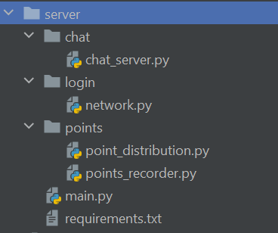

### main.py

*"""Create a database for the team data for each user"""*import sqlite3  
import socket  
import threading  
import chat.chat_server as chat  
  
  
sqliteConnection = sqlite3.connect*(*'teamData.db', check_same_thread=False*)*dataCursor = sqliteConnection.cursor*()*dataCursor.execute*(*"""  
CREATE TABLE IF NOT EXISTS   
teamData (userID int NOT NULL,team string,drivers,cash, UNIQUE(userID), PRIMARY KEY (userID));  
"""*)* #Creates table in the format [userID,team,drivers]  
  
  
def create_driver_points*()*:  
 from points import points_recorder as pr  
 pr.get_drivers*()* pr.get_race_data*()* pr.split_driver_points*()*from login import network as net  
  
  
def main*()*:  
 *"""Create server connection"""* s = socket.socket*(*socket.AF_INET, socket.SOCK_STREAM*)* s.bind*((*'localhost', 9999*))* s.listen*(*5*)* print*(*'Server started'*)* """Create a thread for each client"""  
 while True:  
 client_socket, address = s.accept*()* print*(*f'Connection from *{*address*}* has been established'*)* client = threading.Thread*(*target=handle_client, args=*(*client_socket,*))* # create a thread for each client  
 client.start*()* print*(*f'Thread for *{*address*}* has been created'*)* client.join*()* print*(*f'Thread for *{*address*}* has been joined'*)* sqliteConnection.commit*()* # save changes to the database  
  
  
def handle_client*(*client_socket*)*:  
 user = net.handle_client_login*(*client_socket*)* sqliteConnection.commit*()*def save_team*(*userID, constructor, drivers, spare_cash*)*:  
 *"""Save the team data to the database"""* """IF DATA EXISTS, UPDATE IT"""  
 dataCursor.execute*(*f'INSERT OR REPLACE INTO teamData (userID, team, drivers, cash) VALUES (*{*userID*}*, "*{*constructor*}*", "*{*drivers*}*", *{*spare_cash*}*)'*)* sqliteConnection.commit*()* return True  
  
  
def return_team*(*userID*)*:  
 *"""Return the team data from the database"""* """IF DATA EXISTS, RETURN IT"""  
 data = dataCursor.execute*(*f'SELECT team, drivers, cash FROM teamData WHERE userID = *{*userID*}*'*)*.fetchall*()* return data  
  
def chat_server*()*:  
 *"""Create server connection"""* s = socket.socket*(*socket.AF_INET, socket.SOCK_STREAM*)* s.bind*((*'localhost', 9988*))* s.listen*(*5*)* print*(*'Chat Server started'*)* """Create a thread for each client"""  
 while True:  
 client_socket, address = s.accept*()* client = threading.Thread*(*target=chat.handle_client, args=*(*client_socket,*))* # create a thread for each client  
 client.start*()* client.join*()* print*(*f'Chat Connection from *{*address*}* has been established, started, and joined'*)*if __name__ == '__main__':  
 try:  
 create_driver_points*()* pass  
 except SyntaxError:  
 print*(*'API Offline'*)* '''Start chat server'''  
 threading.Thread*(*target=chat_server*)*.start*()* # create a thread for the chat server  
 '''Start main server'''  
 main*()* sqliteConnection.commit*()* # save changes to the database

### login/network.py

import sqlite3  
import time  
import ast, requests  
from argon2 import PasswordHasher  
import socket  
import threading, json  
from main import save_team, return_team  
  
ph = PasswordHasher*()*sqliteConnection = sqlite3.connect*(*'login/logins.db', check_same_thread=False*)*cursor = sqliteConnection.cursor*()*cursor.execute*(*"CREATE TABLE IF NOT EXISTS logins (userID ,username string,hashpass string, UNIQUE(userID), PRIMARY KEY (userID));"*)*#cursor.execute(f'INSERT INTO logins VALUES (1,"test", "{ph.hash("teststring")}");')  
print*(*cursor.execute*(*"SELECT * FROM logins"*)*.fetchall*())*class Account:  
 def __init__*(*self,username*)*:  
 self.username = username  
 try:  
 if str*(*cursor.execute*(*f'SELECT username FROM logins WHERE username="*{*self.username*}*"'*)*.fetchall*()[*0*])*.split*(*"'"*)[*1*]* != None: # if username exists  
 self.account = True  
 self.password_hash = str*(*cursor.execute*(*f'SELECT hashpass FROM logins WHERE username="*{*username*}*"'*)*.fetchall*()[*0*])*.split*(*"'"*)[*1*]* except IndexError:  
 self.account = False  
  
 def valid_account*(*self*)*:  
 return self.account  
  
 def check_pass*(*self, given_pass*)*:  
 try:  
 if ph.verify*(*self.password_hash, given_pass*)*:  
 return True  
 except Exception:  
 return *[*False,'Invalid Password'*]* def create_record*(*self, password*)*:  
 id = 0  
 while True:  
 try:  
 cursor.execute*(*f'INSERT INTO logins (userID, username, hashpass) VALUES(*{*id*}*,"*{*self.username*}*","*{*password*}*")'*)* print*(*'Account Created'*)* break  
 except Exception:  
 id = id + 1  
  
  
def login*(*account_username, password*)*:   
 user = Account*(*account_username*)* if user.valid_account*()*:  
 result = user.check_pass*(*password*)* else:  
 result = *[*False,'Invalid Username'*]* return result  
  
def register*(*username, password*)*:  
 user = Account*(*username*)* if user.valid_account*()* != True:  
 user.create_record*(*ph.hash*(*password*))* return True  
 else:  
 return *[*False, 'Username Occupied'*]*def handle_client_login*(*client_socket*)*:  
 *"""create a new thread for each client and determine if the client is a new user or returning user so they can login or register"""* request = client_socket.recv*(*1024*)*.decode*()* request = request.split*(*'-~-'*)* print*(*request*)* if request*[*0*]* == 'register':  
 """request in form [register, username, password]"""  
 result = register*(*request*[*1*]*, request*[*2*])* sqliteConnection.commit*()* # commit changes to database  
 client_socket.send*(*str*(*result*)*.encode*())* elif request*[*0*]* == 'login':  
 """request in form [login, username, password]"""  
 result = login*(*request*[*1*]*, request*[*2*])* print*(*result*)* client_socket.send*((*str*(*result*))*.encode*())* if result: # if login is successful  
 return True  
 elif request*[*0*]* == 'save_team':  
 """request in form [save_team, username, password, team_data, driver_data, spare_cash]"""  
 if login*(*request*[*1*]*, request*[*2*])*: # if login is successful  
 userID = cursor.execute*(*f'SELECT userID FROM logins WHERE username = "*{*request*[*1*]}*"'*)*.fetchall*()[*0*][*0*]* result = save_team*(*userID, request*[*3*]*, request*[*4*]*, request*[*5*])* # save team  
 client_socket.send*(*str*(*result*)*.encode*())* elif request*[*0*]* == 'return_team':  
 """request in form [return_team, username, password]"""  
 if (login_result := login(request[1], request[2])): # if login is successful  
 userID = cursor.execute(f'SELECT userID FROM logins WHERE username = "{request[1]}"').fetchall()[0][0]  
 result = return_team(userID) # return team  
 else:  
 result = login_result  
 client_socket.send*(*str*(*result*)*.encode*())* elif request*[*0*]* == 'return_point_data':  
 # get point data from files and send to client  
 team_points = open*(*'points/team_points.json'*)* driver_points = open*(*'points/driver_points.json'*)* team_points = json.load*(*team_points*)* driver_points = json.load*(*driver_points*)* client_socket.send*(*json.dumps*([*team_points, driver_points*])*.encode*())* elif request*[*0*]* == 'return_current_driver_and_constructors':  
 # get current driver and constructor data from files and send to client  
 current_drivers = open*(*'points/current_drivers.txt', 'r'*)* current_constructors = open*(*'points/current_constructors.txt', 'r'*)* current_drivers = current_drivers.read*()* current_constructors = current_constructors.read*()* client_socket.send*(*str*([*current_drivers, current_constructors*])*.encode*())* elif request*[*0*]* == 'get_next_race':  
 try:  
 data = ast.literal_eval*(*requests.get*(*'https://ergast.com/api/f1/current/next.json'*)*.content.decode*())* data = data*[*'MRData'*][*'RaceTable'*][*'Races'*][*0*]* # get useful data  
 race_name = data*[*'raceName'*]* date = data*[*'date'*]* time = data*[*'time'*]* except:  
 race_name, date, time = 'N/A'  
  
 client_socket.send*(*str*([*race_name, date, time*])*.encode*())* else:  
 client_socket.send*(*b'Invalid Request'*)* return False  
  
  
def main():  
 s = socket.socket(socket.AF_INET, socket.SOCK_STREAM)  
 s.bind(('localhost', 9999))  
 s.listen(5)  
 """create a thread for each client"""  
 while True:  
 client_socket, address = s.accept()  
 print(f'Connection from {address} has been established')  
 client = threading.Thread(target=handle_client, args=(client_socket,))  
 client.start()  
 print(f'Thread for {address} has been created')  
 client.join()  
 sqliteConnection.commit()

### points/points_recorder.py

import requests #import needed modules  
import ast  
from threading import Thread, Lock  
import queue  
from datetime import date  
global directory  
directory = 'points/'  
lock = Lock*()*def get_drivers*()*:  
 year = date.today*()*.year  
 driver_data = requests.get*(*f'https://ergast.com/api/f1/*{*year*}*/drivers.json'*)* constructor_data = requests.get*(*f'https://ergast.com/api/f1/*{*year*}*/constructors.json'*)* constructors = ast.literal_eval*(*constructor_data.content.decode*())[*'MRData'*][*'ConstructorTable'*][*'Constructors'*]* drivers = ast.literal_eval*(*driver_data.content.decode*())[*'MRData'*][*'DriverTable'*][*'Drivers'*]* if drivers == *[]* or constructors == *[]*:  
 driver_data = requests.get*(*f'https://ergast.com/api/f1/*{*year-1*}*/drivers.json'*)* constructor_data = requests.get*(*f'https://ergast.com/api/f1/*{*year-1*}*/constructors.json'*)* constructors = ast.literal_eval*(*constructor_data.content.decode*())[*'MRData'*][*'ConstructorTable'*][*'Constructors'*]* drivers = ast.literal_eval*(*driver_data.content.decode*())[*'MRData'*][*'DriverTable'*][*'Drivers'*]* detail_driver_list = *[]* detail_constructor_list = *[]* for driver in drivers:  
 driver_id = driver*[*'driverId'*]* full_name = f"*{*driver*[*'givenName'*]} {*driver*[*'familyName'*]}*"  
 detail_driver_list.append*([*driver_id,full_name*])*#,nationality,DoB,number])  
 for constructor in constructors:  
 constructor_id = constructor*[*'constructorId'*]* name = constructor*[*'name'*]* detail_constructor_list.append*([*constructor_id, name*])* driver_file = open*(*f'*{*directory*}*current_drivers.txt', 'w+'*)* driver_file.write*(*str*(*detail_driver_list*))* driver_file.close*()* constructor_file = open*(*f'*{*directory*}*current_constructors.txt', 'w+'*)* constructor_file.write*(*str*(*detail_constructor_list*))* constructor_file.close*()*def save_to_file*(*queue*)*:  
 file = open*(*f'*{*directory*}*raw_points.csv', 'w+'*)* file.write*(*'year,round,race name,team,team points,driver1,driver1 points,driver2,driver2 points\n'*)* #Write titles of data  
 while finished != True or queue.empty*()* != True:  
 """Loop until queue is empty and finished == True"""  
 file.write*(*queue.get*())* file.close*()*def get_race_data*()*:  
 global q,finished  
 q = queue.Queue*()* finished = False  
 """use threading to run each year in parallel"""  
 threads=*[]* for year in range*(*1950,date.today*()*.year+1*)*:  
 threads.append*(*Thread*(*target=year_loop, args=*(*year,*)))* for thread in threads:  
 thread.start*()* for thread in threads: #End all threads  
 thread.join*()* finished = True  
 save_to_file*(*q*)* #save the queue to a file  
  
  
def year_loop*(*year*)*:  
 #for year in range(1950,date.today().year+1): #Cycle through all years of f1 from 1950 to the current year  
 total_races_in_year = ast.literal_eval*(*requests.get*(*f'http://ergast.com/api/f1/*{*year*}*.json'*)*.content.decode*())[*'MRData'*][*'total'*]* #Get all rounds in the year  
 for race in range*(*1,int*(*total_races_in_year*)*+1*)*: #Cycle through all the rounds in the year  
 race_data = ast.literal_eval*(*requests.get*(*f'http://ergast.com/api/f1/*{*year*}*/*{*race*}*/results.json'*)*.content.decode*())* #Get the race data  
 try:  
 assign_driver_points*(*race_data*)* #,quali_data)  
 except IndexError as a:  
 print*(*f"*{*a*} {*year*}*"*)*def assign_driver_points*(*rData*)*: #use race data to assign points to the driver  
 team_dict = *{}* year = rData*[*'MRData'*][*'RaceTable'*][*'Races'*][*0*][*'season'*]* #Get race year  
 round = rData*[*'MRData'*][*'RaceTable'*][*'Races'*][*0*][*'round'*]* #Get race number  
 rName = rData*[*'MRData'*][*'RaceTable'*][*'Races'*][*0*][*'raceName'*]* #Get race name  
 try:  
 for driver in rData*[*'MRData'*][*'RaceTable'*][*'Races'*][*0*][*'Results'*]*:  
 constructor = driver*[*'Constructor'*][*'name'*]* #Get drivers team  
 driver_id = driver*[*'Driver'*][*'driverId'*]* #Get drivers name  
 finish_position = driver*[*'position'*]* #Get finish pos  
 grid_position = driver*[*'grid'*]* #Get starting position  
 try: fastest_lap_position = driver*[*'FastestLap'*][*'rank'*]* #Get fastest lap rank  
 except KeyError: fastest_lap_position = 22  
 if constructor not in team_dict: #Combines all drivers of the same teams in a dictionary  
 team_dict*[*constructor*]* = *[]* team_dict*[*constructor*]*.append*({*'driver':driver_id,'fastPosition':fastest_lap_position,'gPosition':grid_position,'fPosition':finish_position*})* #make a dictionary which contains all driver data needed and groups drivers by team  
 for team in team_dict:  
 driver1 = team_dict*[*team*][*0*]* try: driver2 = team_dict*[*team*][*1*]* except IndexError: driver2 = *{*'driver': 'n/a', 'fastPosition': 22, 'gPosition': '22', 'fPosition': '22'*}* #If no second driver exists, use filler data  
 points = get_points*(*driver1,driver2*)* #get the driver and constructors points  
 save_points*([*driver1*[*'driver'*]*,points*[*'driver1'*]]*,*[*driver2*[*'driver'*]*,points*[*'driver2'*]]*,*[*team,points*[*'constructor'*]]*,year,round,rName*)* except KeyError as a:  
 print*(*a*)*def save_points*(*driver1,driver2,team,year,round,rName*)*: # save the points to the queue  
 if int*(*year*)* == date.today*()*.year: # If it is this year, increase all points 10x  
 team*[*1*]* = int*(*team*[*1*])*\*10  
 driver1*[*1*]* = int*(*driver1*[*1*])*\*10  
 driver2*[*1*]* = int*(*driver2*[*1*])*\*10  
 lock.acquire*()* # Lock the queue  
 q.put*(*f"*{*year*}*,*{*round*}*,*{*rName*}*,*{*team*[*0*]}*,*{*team*[*1*]}*,*{*driver1*[*0*]}*,*{*driver1*[*1*]}*,*{*driver2*[*0*]}*,*{*driver2*[*1*]}*\n"*)* #Add the data to the queue  
 lock.release*()* # Unlock the queue  
  
  
def get_points*(*driver1_data,driver2_data*)*: #Get all data required to calculate points for both drivers  
 drivers_data = *[[*int*(*driver1_data*[*'fPosition'*])*,int*(*driver1_data*[*'gPosition'*])*,int*(*driver1_data*[*'fastPosition'*])*,int*(*driver2_data*[*'fPosition'*])]*,  
 *[*int*(*driver2_data*[*'fPosition'*])*,int*(*driver2_data*[*'gPosition'*])*,int*(*driver2_data*[*'fastPosition'*])*,int*(*driver1_data*[*'fPosition'*])]]* #Creates a list so that all the data can be inputed into the loop  
 driver_points = *[]* team_points = 0  
 from points import point_distribution as pd  
 for i in range*(*0,2*)*: #loop twice to get both drivers points  
 fPos = drivers_data*[*i*][*0*]* #Extract all data from the list  
 gPos = drivers_data*[*i*][*1*]* fLapPos = drivers_data*[*i*][*2*]* teammatePos = drivers_data*[*i*][*3*]* points=0  
 """Race Points"""  
 try:   
 points = points + pd.assign_points*[*'DriverPoints'*][*'Race'*][*'Results'*][*str*(*fPos*)]* #add points to driver for finishing finishing top 10 or minus 25 for not finishing  
 team_points = team_points + pd.assign_points*[*'Constructor'*][*'Race'*][*'Results'*][*str*(*fPos*)]* #Add points to team  
 except KeyError:   
 points = 0  
 points = points + *((*int*(*gPos*)* - int*(*fPos*))*\* pd.assign_points*[*'DriverPoints'*][*'Race'*][*'PGFG'*])* #add points to driver for position gained from grid  
 team_points = team_points + *((*int*(*gPos*)* - int*(*fPos*))* * pd.assign_points*[*'Constructor'*][*'Race'*][*'PGFG'*])* if fLapPos == 1:   
 points = points + pd.assign_points*[*'DriverPoints'*][*'Race'*][*'fLap'*]* #Add points to driver for achiving fastest lap  
 team_points = team_points + pd.assign_points*[*'Constructor'*][*'Race'*][*'fLap'*]* #Add points to team for fastest lap   
 if fPos > teammatePos:   
 points = points + pd.assign_points*[*'DriverPoints'*][*'Race'*][*'FAT'*]* #add points for finishing above teammate  
 elif fPos < teammatePos:   
 points = points + pd.assign_points*[*'DriverPoints'*][*'Race'*][*'FBT'*]* #add points for finishing below teammate  
 try:team_points = team_points + pd.assign_points*[*'Constructor'*][*'Race'*][*'Results'*][*str*(*fPos*)]* #Add points to team for result in race  
 except KeyError:   
 pass  
 """Quallifying Points"""  
 try:   
 points = points + pd.assign_points*[*'DriverPoints'*][*'Qualifying'*][*'Results'*][*gPos*]* #Add driver points for qually pos  
 team_points = team_points + pd.assign_points*[*'Constructor'*][*'Qualifying'*][*'Results'*][*gPos*]* #Add team points for qually pos  
 except KeyError:   
 pass  
 if gPos <= 15:  
 points = points + pd.assign_points*[*'DriverPoints'*][*'Qualifying'*][*'RQ2'*]* #Add points for qually positions above 15  
 team_points = team_points + pd.assign_points*[*'Constructor'*][*'Qualifying'*][*'RQ2'*]* #Add team points for qually positions above 15  
 if gPos <= 10:  
 points = points + pd.assign_points*[*'DriverPoints'*][*'Qualifying'*][*'RQ3'*]* #Add points for qually positions above 10  
 team_points = team_points + pd.assign_points*[*'Constructor'*][*'Qualifying'*][*'RQ3'*]* #Add team points for qually positions above 10  
 driver_points.append*(*points*)* return *{*'constructor':team_points,'driver1':driver_points*[*0*]*,'driver2':driver_points*[*1*]}*def split_driver_points*()*:  
 data = open*(*f'*{*directory*}*raw_points.csv','r'*)*.readlines*()[*1:*]* teams = *{}* drivers = *{}* for line in data:  
 """Convert the file data back into useful variables"""  
 line = line.split*(*','*)* team = line*[*3*]* team_points = line*[*4*]* driver1 = line*[*5*]* driver1_points = line*[*6*]* driver2 = line*[*7*]* driver2_points = line*[*8*]* """take all points for each driver and append them to a list in a dictionary for that driver"""  
 variable_set = *[[*driver1,driver1_points,drivers*]*,*[*driver2,driver2_points,drivers*]*,*[*team,team_points,teams*]]* for driver in variable_set: # iterate through each driver  
 if driver*[*0*]* in driver*[*2*]*:  
 driver*[*2*][*driver*[*0*]]*.append*(*int*(*driver*[*1*]))* else:  
 driver*[*2*][*driver*[*0*]]* = *[*int*(*driver*[*1*])]* """Add the points in the list together and replace the list with a total"""  
 for team in teams:  
 teams*[*team*]*=sum*(*teams*[*team*])* for driver in drivers:  
 drivers*[*driver*]*=sum*(*drivers*[*driver*])* """Sort each dictionary so its easier to read"""  
 drivers_sorted=dict*(*sorted*(*drivers.items*()*,key= lambda x:x*[*1*]))* teams_sorted=dict*(*sorted*(*teams.items*()*,key= lambda x:x*[*1*]))* """save the points to a json file"""  
 save_final_points*(*drivers_sorted,'driver_points.json'*)* save_final_points*(*teams_sorted,'team_points.json'*)* print*(*'Team and Driver points Compleated'*)*def save_final_points*(*points,file*)*:  
 file = open*(*directory+file,'w+'*)* file.write*(*str*(*points*)*.replace*(*"'",'"'*))* file.close  
  
if __name__ == '__main__':  
 import time  
 get_drivers*()* start = time.time*()* get_race_data*()* print*(*f"Runtime of the program is *{*time.time*()* - start*}*"*)* split_driver_points*()*

### points/points_distribution.py

#Points given for tasks  
assign_points=*{* 'DriverPoints':*{* 'Race':*{* 'Results':*{* '1':25,  
 '2':18,  
 '3':15,  
 '4':12,  
 '5':10,  
 '6':8,  
 '7':6,  
 '8':4,  
 '9':2,  
 '10':1,  
 'F':-25, #F,D,W,R,N is DNF  
 'D':-25,  
 'W':-25,  
 'R':-25,  
 'N':-25  
 *}*,  
 'fLap':1, #Fastest Lap  
 'PGFG':1, #Points per Position gained From grid  
 'PLFG':-1, #Points per Position lost From grid  
 'FAT':3, #Finished above teammate  
 'FBT':-3, #Finished below teammate  
 *}*,  
 'Qualifying':*{* 'Results':*{* '1':3,  
 '2':2,  
 '3':1,  
 *}*,  
 'RQ2':5, #Reached Q2  
 'RQ3':5, #Reached Q3  
 'QBT':-3, #Quallified Below Teammate  
 'QAT':3 #Quallified Above Teammate  
 *}  
 }*,  
 'Constructor':*{* 'Race':*{* 'Results':*{* '1':25+3,  
 '2':18+3,  
 '3':15+3,  
 '4':12+3,  
 '5':10+3,  
 '6':8+3,  
 '7':6+3,  
 '8':4+3,  
 '9':2+3,  
 '10':1+3,  
 'F':-25, #F,D,W,R,N is DNF  
 'D':-25,  
 'W':-25,  
 'R':-25,  
 'N':-25  
 *}*,  
 'fLap':1, #Fastest Lap  
 'PGFG':1, #Points per Position gained From grid  
 'PLFG':-1, #Points per Position lost From grid  
 *}*,  
 'Qualifying':*{* 'Results':*{* '1':3,  
 '2':2,  
 '3':1,  
 *}*,  
 'RQ2':5, #DriverReached Q2  
 'RQ3':5, #Driver Reached Q3  
 'BQ3':3, #Both drivers reach Q3  
 *}  
 }  
 }*

### chat/chat_server.py

import ast  
chat_list = *[]*def handle_client*(*client_socket*)*:  
 *"""  
 Handle a client connection for the chat server.  
 """* # Receive the message  
 request = client_socket.recv*(*1024*)* request = ast.literal_eval*(*request.decode*())* if request*[*0*]* == 'send':  
 chat_list.append*(*request*[*1*])* if request*[*0*]* == 'get_chats':  
 chat_log = 'Chat:'  
 for item in chat_list:  
 chat_log = chat_log + '\n' + item  
 client_socket.send*(*chat_log.encode*())* # Send the message back  
  
 # Close the connection  
 client_socket.close*()*